**MNCH Survey System**

**User Guide**

# MNCH Survey System User Guide

The Ministry of Health Survey and Analysis System is a tool designed to monitor and evaluate the factors affecting maternal, newborn, child health and IMCI Follow-Up Tool within a region.

The system functions by inserting (save) form data from surveys carried out in hospitals and other medical facilities within the region, and then analyses and presents the information in a complete and measurable format indicating the specific factors affecting maternal neonatal, infant health and IMCI Follow-Up Tool within the region.

Table of Contents

MNCH Survey System User Guide b

Overview 2

Getting Started 3

System User Interface 4

Main Menu 4

Left Sidebar 5

Header 6

Body 7

Right Sidebar 8

Header 9

Main Menu 10

Surveys Menu 12

Analytics Menu 14

Left Sidebar (Current Surveys) 16

Right Sidebar (Survey Analysis) 18

Body (Child Health Reporting Rates) 20

FAQs & 'How To' 23

How to Perform a Survey 23

I. How to perform the Maternal and Neonatal Health Survey 23

How to Log in 25

Section 01 of 08 – FACILITY INFORMATION 28

Section 02 of 08 – DELIVERIES CONDUCTED DATA, PROVISION OF BEmONC FUNCTIONS 30

Section 03 of 08 – GUIDELINES, JOB AIDS AND TOOLS AVAILABILITY 31

Section 04 of 08 – STAFF TRAINING 32

Section 05 of 08 – COMMODITY AVAILABILITY 33

Section 06 of 08 – COMMODITY USAGE 35

Section 07 of 08 – EQUIPMENT AVAILABILITY AND FUNCTIONALITY 37

Section 08 of 08 – COMMUNITY STRATEGY 38

II. How to perform the Child Health Survey 38

How to Log in 40

Section 01 of 09 – FACILITY INFORMATION 44

Section 02 of 09 – GUIDELINES, JOB AIDS AND TOOLS 46

Section 03 of 09 - SERVICE DELIVERY & QUALITY OF DIAGNOSIS 48

Section 04 of 09 – COMMODITY AND BUNDLING AVAILABILITY 50

Section 05 of 09 – REVIEW OF RECORDS 51

Section 06 of 09 – EQUIPMENT AVAILABILITY AND STATUS 52

Section 07 of 09 – SUPPLIES AVAILABILITY 53

Section 08 of 09 – SUPPLIES AVAILABILITY 55

Section 09 of 09 – RESOURCE AVAILABILITY 56

III. How to perform the IMCI Follow-Up Tool Survey 57

How to Log in 59

Section 01 of 05 – FACILITY INFORMATION 63

Section 02 of 05 – OBSERVATION OF CASE MANAGEMENT 65

Section 03 of 05 – DOES THE HCW CHECK FOR THE FOLLOWING 67

Section 04 of 05 – CONSULTATION OBSERVATION 69

Section 05 of 05 – ASSESSMENT OUTCOME 70

How to Analyze a Survey 71

How to access the Maternal Health Analysis 72

How to access the Child Health analysis 72

How to access the IMCI Follow-Up Tool analysis 73

How to Analyze a County 74

Analytics Summary for an Unselected County 75

Analytics Summary for a Selected County 78

MNH Analytics 82

FACILITY STATISTICS 82

Nurses Deployed 83

Beds in Facility 83

Services 83

Health Facility Management 87

Deliveries 87

HIV Testing 87

Job Aids 87

Guidelines Availability 87

Community Strategy 90

Staff Training 94

Signal Functions 95

CEmONC Signal Function 95

BEmONC Signal Function 95

BEmONC Signal Function Challenges 95

Commodities 95

Commodity Availability 96

Commodity Unavailability 99

Commodity Location 103

Commodity Quantities 107

Commodity Suppliers 111

EQUIPMENT 116

Equipment Availability 116

Equipment Location 116

Equipment Functionality 116

Supplies 116

Supplies Availability 117

Supplies Location 120

Suppliers 121

Hardware 124

Hardware Availability 124

Resources 125

Resource Availability 126

Resource Location 129

CH Analytics 133

FACILITY STATISTICS 134

Community Strategy 134

Guidelines Availability 134

Staff Training 134

Services Offered 134

Danger Signs 134

Actions Performed 138

Counsel Given 143

Tools in a Given Unit 147

Consultation 151

Health Services 151

Case Management 151

IMCI Consultation Room 151

COMMODITIES 151

Commodity Availability 152

Commodity Reasons for Unavailability 152

Commodity Location 152

Commodity Quantities 152

Commodity Suppliers 152

BUNDLING 152

Commodity Bundling Availability 152

Commodity Reasons for Bundling Unavailability 152

Bundling Location 152

Bundling Quantities 152

Bundling Suppliers 153

Diarrhoea Cases 153

Case Numbers 154

Case Treatment 157

PNEUMONIA CASES 158

Case Numbers 158

Case Treatment 158

MALARIA CASES 158

Case Numbers 158

Case Treatment 158

ORT CORNER 158

ORT Corner Assessment 160

ORT Corner Equipment Availability 165

ORT Corner Equipment Functionality 169

ORT Corner Equipment Location 173

SUPPLIES 176

Supplies Availability 176

Suppliers 176

RESOURCES 176

Resource Availability 177

Resource Location 177

This page has been intentionally left blank.

# Overview

The MOH survey and analysis tool simplifies an otherwise complicated task of sifting through tons of data to provide a clear cut glance at the factors affecting maternal, IMCI Follow-Up Tool and newborn and child health.

The multiple factors affecting maternal, newborn, IMCI Follow-Up Tool and child health would be considerably difficult to measure and compare within a region due to the sheer number of medical facilities within a region.

This system comes in to help with the aggregation of that data allowing for easier comparisons of regional information and other tasks.

For instance, tracking of cholera or diarrhoea cases in different regions, the availability of equipment to treat these cases, and the measures put in place to reduce re-occurrence can be tracked and compared by this system.

# Getting Started

Please read the topics that follow to quickly get started with the system.

The introductory topics shall give you a brief overview of the system concept taking you through the system user interfaces which you shall encounter while performing various tasks.

It shall only take you a few minutes to realize how simple it is to perform and submit the details of a survey and to analyze the results of that survey per region.

# System User Interface

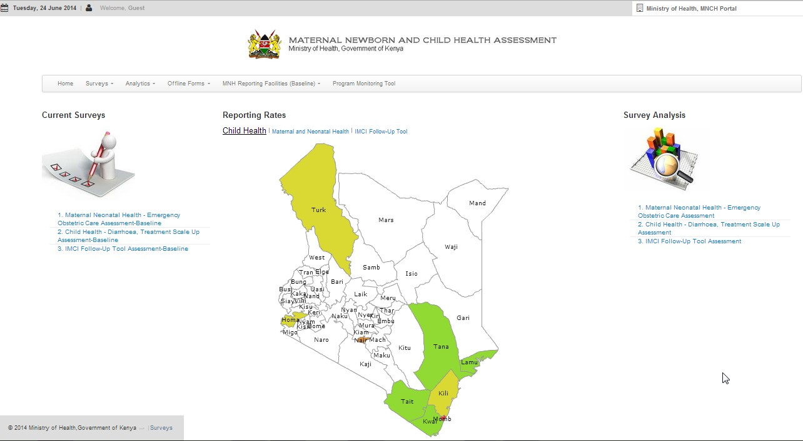

The figure above illustrates a brief overview of the system home page



## Main Menu

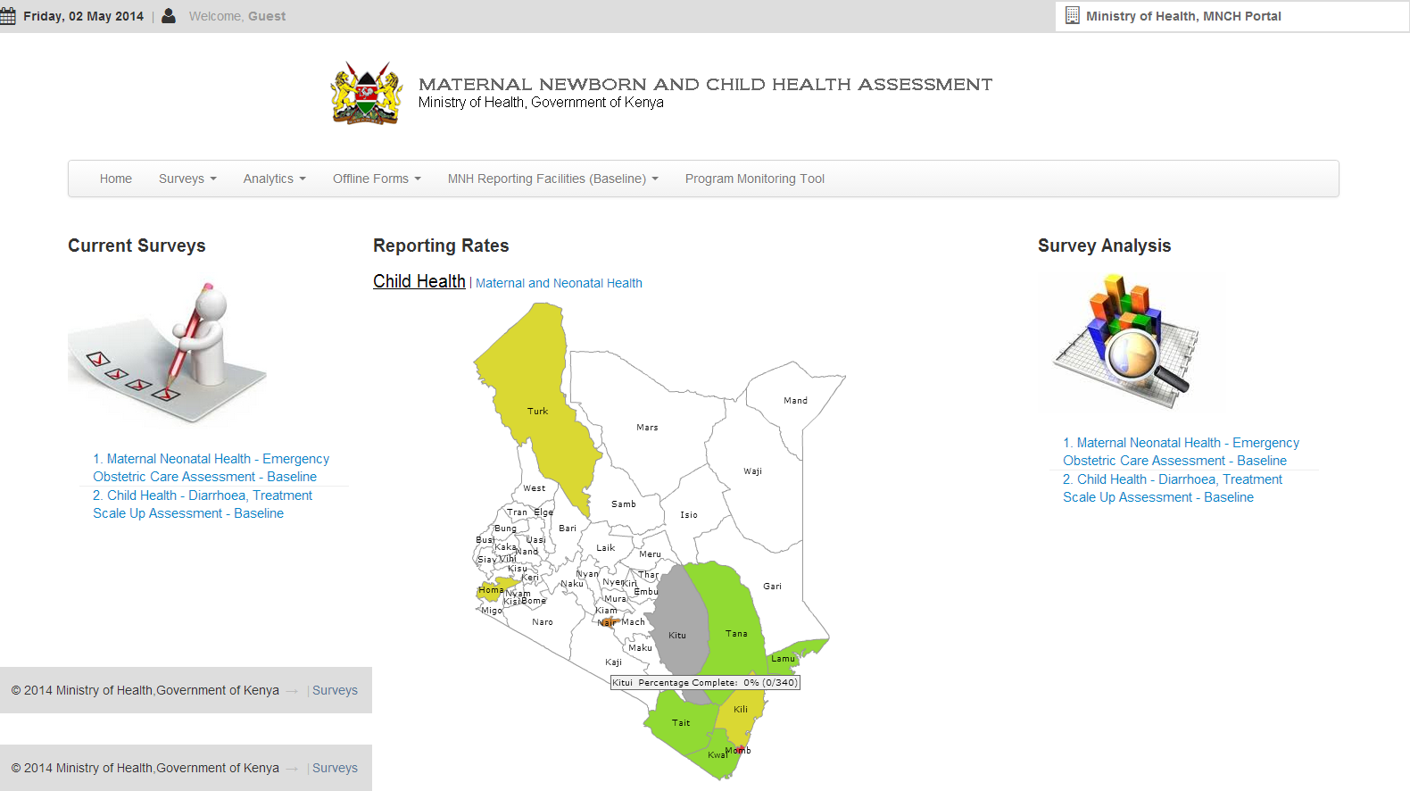

The Main Menu provides access to common operations within the system. Its 6 sub-menus are as follows;

* Home: by clicking this, the user is brought back to this very page which is the 'home page'.
* Surveys: a user planning to perform a survey should click this item and pick a specific survey.
* Analytics: a user planning to perform an analysis of a survey should click this item and pick the specific analysis they are interested in.
* Offline Forms: a user may perform a survey using PDF hardcopies that are similar to the online surveys in the website using the offline forms’ link to download the form
* MNH Reporting Facilities(Baseline): This provides a link to view the completed and partially completed surveys of certain facilities
* Program Monitoring Tool: A link that takes the user to view the analysis or data carried out for different counties in the country

The Main Menu is explained in detail in the next section.



## Left Sidebar

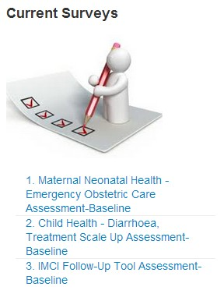

The Left Sidebar or 'Current Surveys' contains the surveys being carried out;

* the Maternal Neonatal health survey,
* the Child Health survey, and
* the IMCI Follow-Up Tool survey

Clicking either of these shall direct you to the relevant page to perform the specified survey.

The Left Sidebar is explained in detail in the next section.



## Header

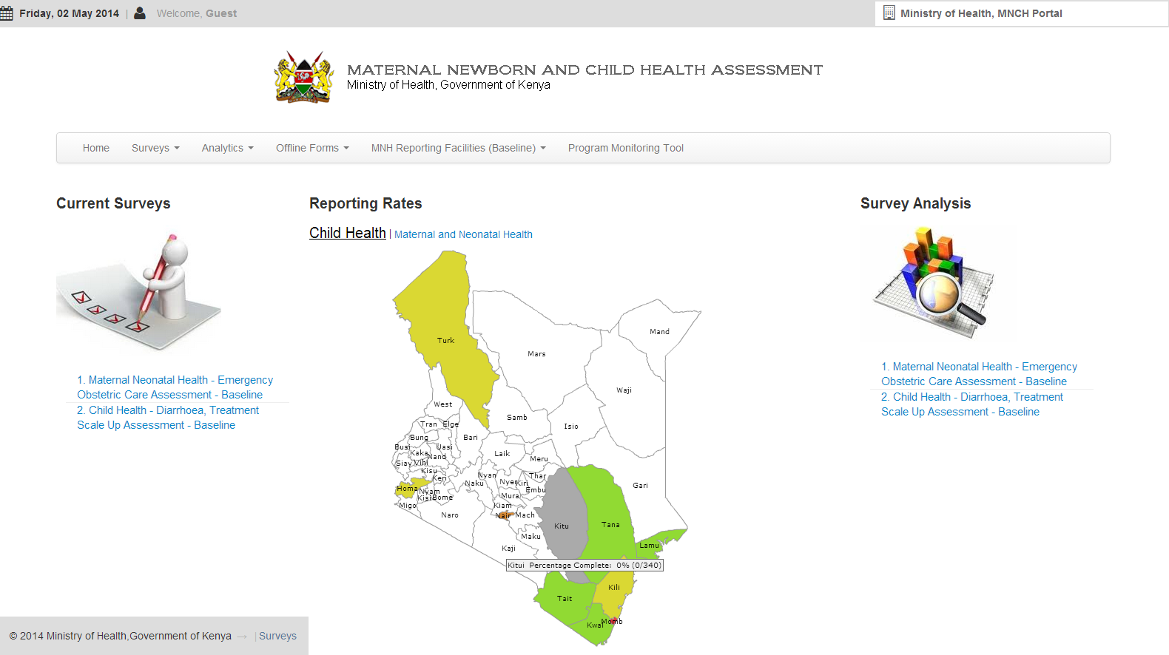

The header describes the top most section of the page. It contains the following:

* The current date as shown in the left most corner
* A user indicator showing who is logged into the system
* An I.D at the right most corner

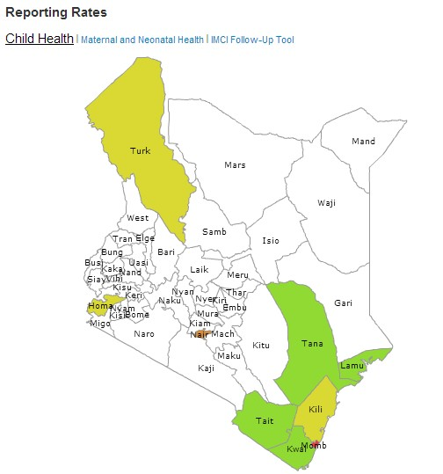

## Body

The main body contains a map of the region divided into its relevant counties.

The counties that have a color indicator signify surveys in progress.

The counties that are either white or grey signify areas where surveys are yet to begin or to be submitted.

The Main Body is explained in detail in the next section.



## Right Sidebar

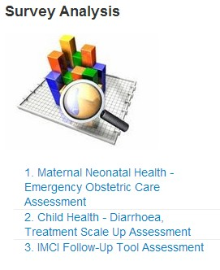

The Right Sidebar or 'Survey Analytics' contains the current survey analytics being performed;

* the Maternal Neonatal health survey assessment,
* the Child Health survey assessment, and
* the IMCI Follow-Up assessment

Clicking either of these shall direct you to the relevant page to perform an analysis on the specified survey.

The Right Sidebar is explained in detail in the next section.

### Header

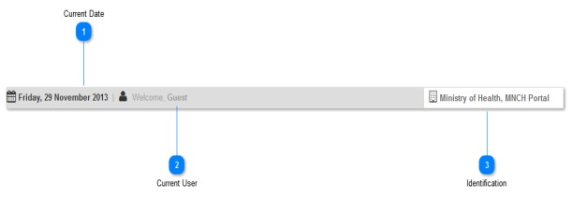

The figure above illustrates the various parts of the header.



**Current Date**



This indicates the current date as and when you access the system.



**Current User**



This indicates the currently logged in user.

You shall be required to log in before entering survey data.



**Identification**



This is an identification indicator. It gives the system an identity.

### Main Menu

4

2

5



R

* r





3

6

1

R

R

The figure above illustrates the main menu.

R



**Home Menu**

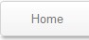

Clicking this menu item shall return you to the main page of the system also known as the home page.



**Surveys Menu**

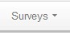

This menu item represents the various surveys capable of being performed by the system.

Clicking this menu item shall result in a dropdown sub-menu with three choices:

* Maternal Neonatal Health Baseline
* Child Health Baseline
* IMCI Follow-Up Tool Baseline

Select either of them to input their respective survey data.

The surveys menu shall be explained in detail in the next section.



**Analytics Menu**

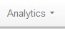

This menu item represents the various analytics performed by the system.

Clicking this menu item shall result in a dropdown sub-menu with three choices:

* Maternal Neonatal Health Baseline survey analytics
* Child Health Baseline survey analytics
* Follow-Up Tool after IMCI Training analytics

Select either of them to review the relevant survey analytics.

The analytics menu shall be explained in detail in the next section.

4

**Offline Forms**

R



This menu item represents the offline forms in PDF form.

Clicking this menu item shall result in a dropdown sub-menu with three choices:

* Maternal Neonatal Health survey form
* Child Health survey form
* Follow-Up Tool after IMCI Training form

5

**MNH Reporting Facilities**

R



This menu item represents the list of reporting facilities.

Clicking this menu item shall result in a dropdown sub-menu with two choices:

* List of Completed Facilities
* List of Partially Completed Facilities

6

**Program Monitoring Tool**

* r





This menu item represents the link to the Program Monitoring Tool.

Clicking this menu item shall redirect you to this system

### Surveys Menu



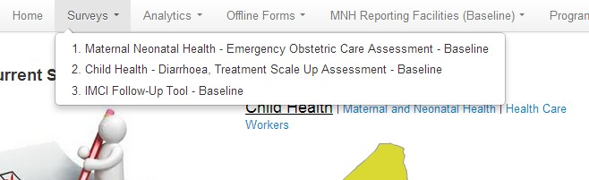

The figure above illustrates the 'surveys menu' and its components.



**Surveys Menu**

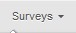

This menu item represents the various surveys capable of being performed by the system.

Clicking this menu item shall result in a dropdown sub-menu with two choices:

* Maternal Neonatal Health Baseline
* Child Health Baseline
* IMCI Follow-Up Tool Baseline



**Surveys Sub-Menu**

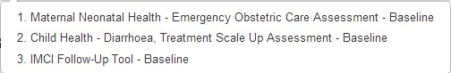

As indicated in the figure, the sub-menu has 3 options for 3 different surveys:

* Maternal Neonatal Health Baseline
* Child Health Baseline
* IMCI Follow-Up Tool baseline



**Maternal Health Survey**



Selecting/Clicking this shall direct you toward performing a maternal health survey.

For a detailed step by step tutorial on how to perform a maternal health survey, refer to the FAQs section.



**Child Health Survey**



Selecting/Clicking this shall direct you toward performing a child health survey.

For a detailed step by step tutorial on how to perform a child health survey, refer to the FAQs section.



**IMCI Follow-Up Tool Survey**

##### 



Selecting/Clicking this shall direct you toward performing an IMCI Follow-Up Tool survey.

For a detailed step by step tutorial on how to perform an IMCI Follow-Up Tool survey, refer to the FAQs section.

### Analytics Menu



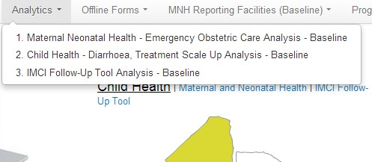

The figure above illustrates the 'analytics menu' and its components.



**Analytics Menu**

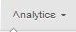

This menu item provides a direct link to the various analytics capable of being performed by the system.

Clicking this menu item shall result in a dropdown sub-menu with three choices:

* Maternal Neonatal Health Analytics
* Child Health Analytics
* IMCI Follow-Up Tool Analytics



**Analytics Sub-Menu**

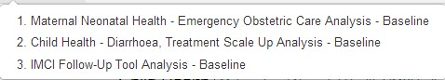

As indicated in the figure, the sub-menu has 3 options for analytics:

* Maternal Neonatal Health Analytics
* Child Health Analytics
* IMCI Follow-Up Tool Analytics



**Maternal Health Analytics**



Selecting/Clicking this shall direct you toward reviewing the maternal health analytics.

For a detailed step by step tutorial on how to review maternal health analytics, refer to the FAQs section.



**Child Health Analytics**



Selecting/Clicking this shall direct you toward reviewing the child health analytics.

For a detailed step by step tutorial on how to review child health analytics, refer to the FAQs section.



**IMCI Follow-Up Tool Analytics**



Selecting/Clicking this shall direct you toward reviewing the IMCI Follow-Up Tool analytics.

For a detailed step by step tutorial on how to review IMCI Follow-Up Tool analytics, refer to the FAQs section.

### Left Sidebar (Current Surveys)



The figure above illustrates the 'left sidebar' and its components.



**Left Sidebar**



The Left Sidebar or 'Current Survey' section represents the various surveys capable of being performed by the system.

Selecting/Clicking either of the choices shall direct you toward performing a maternal health survey or child health survey.

For a detailed step by step tutorial on how to perform a maternal health survey, child health survey or IMCI Follow-Up Tool survey, refer to the FAQs section.



**Maternal Neonatal Health Survey**

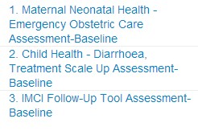

Selecting/Clicking the 1st option shall direct you toward performing a maternal health survey.

For a detailed step by step tutorial on how to perform a maternal health survey, refer to the FAQs section.



**Child Health Survey**



Selecting/Clicking the 2nd option shall direct you toward performing a child health survey.

For a detailed step by step tutorial on how to perform a child health survey, refer to the FAQs section.



**IMCI Follow-Up Tool Survey**



Selecting/Clicking the 3rd option shall direct you toward performing an IMCI Follow-Up Tool survey.

For a detailed step by step tutorial on how to perform an IMCI Follow-Up Tool survey, refer to the FAQs section.

### Right Sidebar (Survey Analysis)



The figure above illustrates the 'right sidebar' and its components.



**Right Sidebar**



The Right Sidebar or 'Survey Analysis' section represents the various analytics capable of being performed by the system.

Selecting/Clicking either of the choices shall direct you toward reviewing the analytics for a maternal health survey, child health survey or the IMCI Follow-Up Tool survey.

For a detailed step by step tutorial on how to review the analytics for a maternal health survey, child health survey or the IMCI Follow-Up survey, refer to the FAQs section.



**Maternal Neonatal Health Analysis**

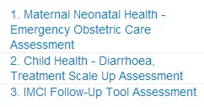

Selecting/Clicking the 1st option shall direct you toward reviewing the analytics for a maternal health survey.

For a detailed step by step tutorial on how to perform a maternal health analysis, refer to the FAQs section.



**Child Health Analysis**



Selecting/Clicking the 2nd option shall direct you toward reviewing the analytics for a child health survey.

For a detailed step by step tutorial on how to perform a child health analysis, refer to the FAQs section.

**IMCI Follow-Up Tool Analysis**





Selecting/Clicking the 3rd option shall direct you toward reviewing the analytics for an IMCI Follow-Up Tool survey.

For a detailed step by step tutorial on how to perform an IMCI Follow-Up Tool analysis, refer to the FAQs section.

### Body (Child Health Reporting Rates)

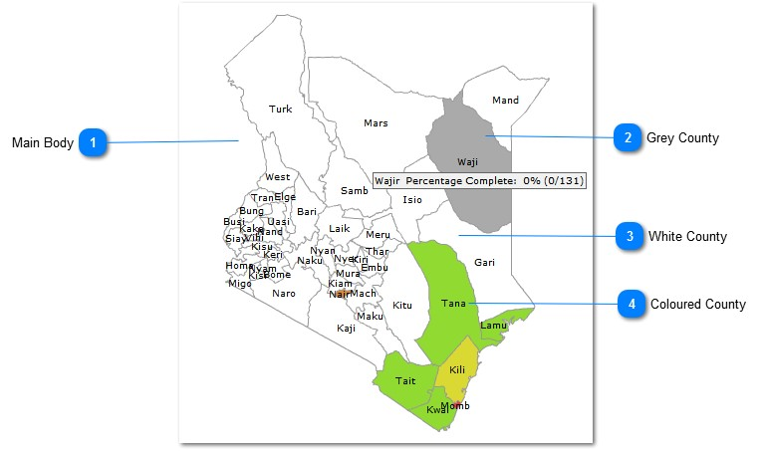

The figure above illustrates the 'body' and its components.



**Main Body**



The main body of the page is represented by a figure of the region (country) divided into its various counties.

The counties appear color coded depending on the extent of the survey process:

* A grey or white county indicates that the survey process is yet to begin or the survey data is yet to be entered into the system.
* A colored county indicates that the survey process is either ongoing or complete.

To check the overall progress of a survey in a county, simply place the cursor over the county in question and a progress bar shall appear as shown in No.2 above.

To access the analytics of a particular county, click on the county of your choice and you shall be redirected to its analytics section.



**Grey County**

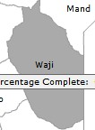

* A grey county indicates that the survey process is yet to begin or the survey data is yet to be entered into the system.
* A white colored county turns grey once you move the cursor over it.
* A progress bar, showing percentage completion, appears once you move your cursor over the white county.



**White County**

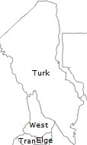

* A white county indicates that the survey process is yet to begin or the survey data is yet to be entered into the system.
* A white colored county turns grey once you move the cursor over it.
* A progress bar, showing percentage completion, appears once you move your cursor over the white county.



**Colored County**

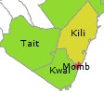

* A colored county indicates that the survey process is either ongoing or complete.
* A progress bar, showing percentage completion, appears once you move your cursor over the county.
* Clicking on a county shall result in you being directed to its analytics page.

# FAQs & 'How To'

This section shall contain answers on **F**requently **A**sked **Q**uestions and various '**How To**' queries on performing various tasks within the system.

### How to Perform a Survey

This section shall guide you, step by step, on how to perform and enter the details of a survey for a particular region.

# How to perform the Maternal and Neonatal Health Survey

This section shall outline, step by step, how to perform or insert data for the maternal health survey.

The following steps shall be observed in detail:

##### How to access the survey

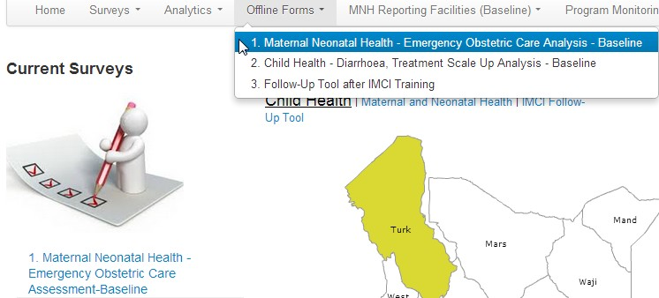

The figure above illustrates how to access the maternal neonatal health survey.



**Link 01**

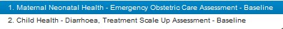

Click this link to access the maternal neonatal health survey



**Link 02**

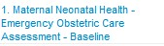

Click this link to access the maternal neonatal health survey

## How to Log in

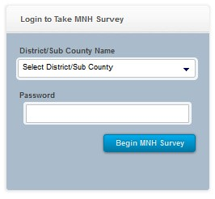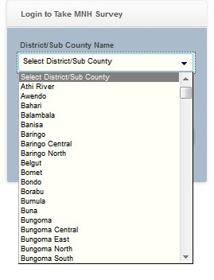

01. Once you access the survey, the window

02. Select a region as indicated above shall appear

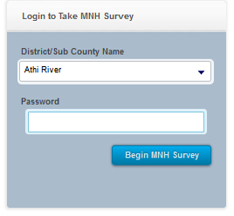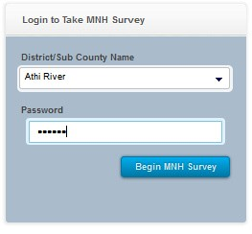

03. In the above example 'Athi River' is ******. Enter the password provided by your selected administrator and click on 'Begin MNH Survey'

##### How to select a facility

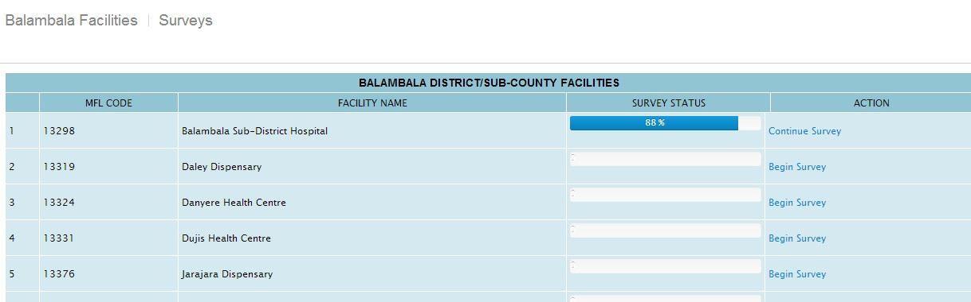

The figure above illustrates part a list of facilities you are presented with, once you log in.

**Survey Status**

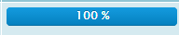

This indicates that the survey for this particular facility has been performed and completed.

**Action**

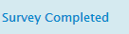

The survey was completed therefore you cannot take survey.

**Survey Status**



This indicates the survey was performed but not completed due to various reasons such as power interruptions. The user can then continue with the survey.

**Action**

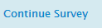

By clicking on the “Continue Survey” it loads the exact section where survey had been left and the user can continue with the survey.

**Survey Status**

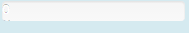

This indicates the survey has not been taken in this particular facility.

**Action**



By clicking on the “Begin Survey” it takes you to the first section of the survey for this particular facility.

##### How to fill in the forms

This section shall outline the various forms that collect survey data for the maternal health survey.

The form is divided into 8 parts or sections for simplification purposes.

### Section 01 of 08 – FACILITY INFORMATION

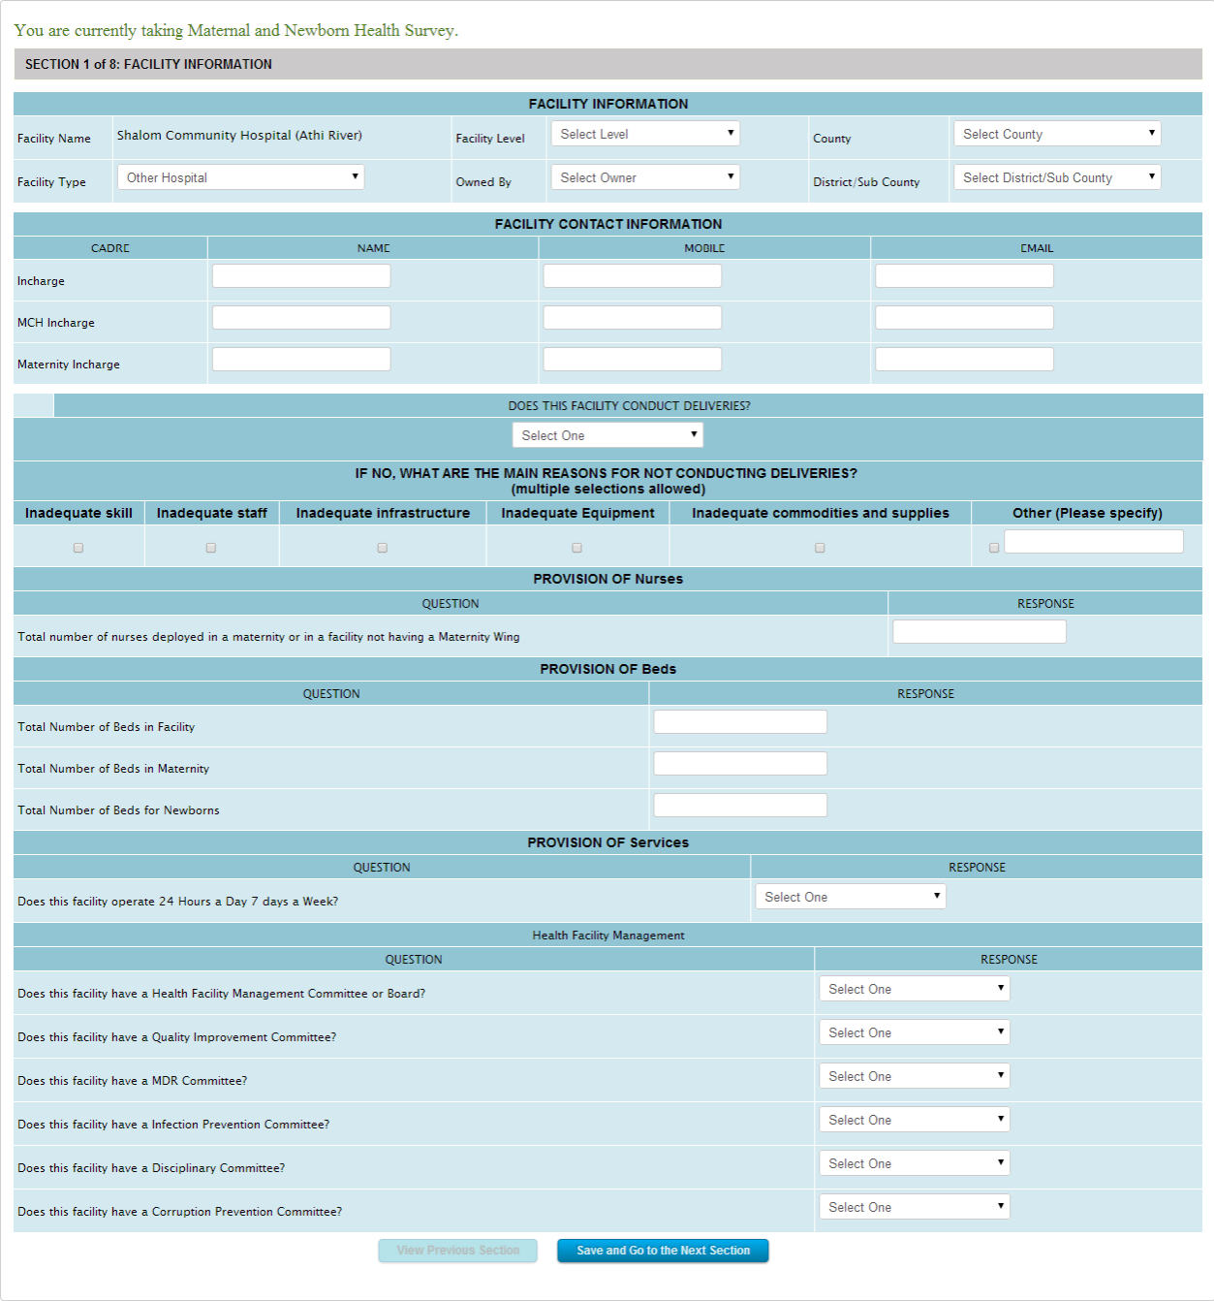

The figure above illustrates the first section of the survey form.



**Selected Facility**



Displays the facility location you selected when you logged into the system.

In this case, we selected 'Balambala' while logging in.



**Selected Survey**



Displays the survey that you are currently performing



**Form Section**



Simply indicates which section of the form you are currently filling.



**Click to Proceed**



Click this button after filling in all the form details, to save the data and proceed to the next section.

### Section 02 of 08 – DELIVERIES CONDUCTED DATA, PROVISION OF BEmONC FUNCTIONS

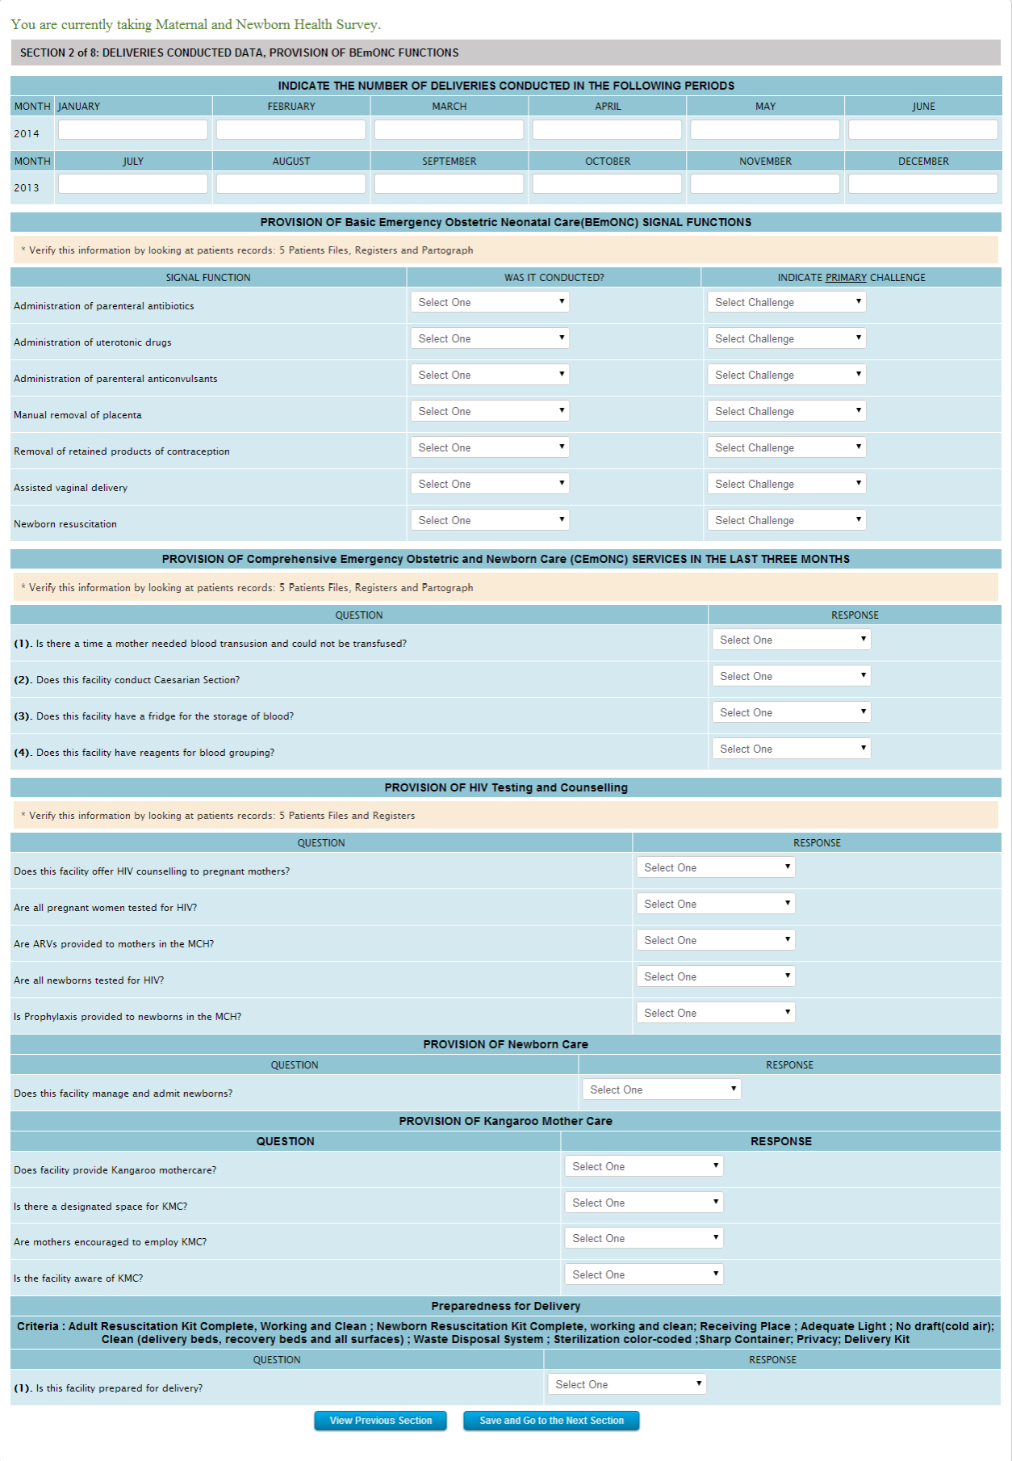

The figure above illustrates the second section of the survey form.



**Click to go back**



Click this button if you would like to go back to the previous form section.



**Click to Proceed**



Click this button after filling in all the form details, to save the data and proceed to the next section.

### Section 03 of 08 – GUIDELINES, JOB AIDS AND TOOLS AVAILABILITY

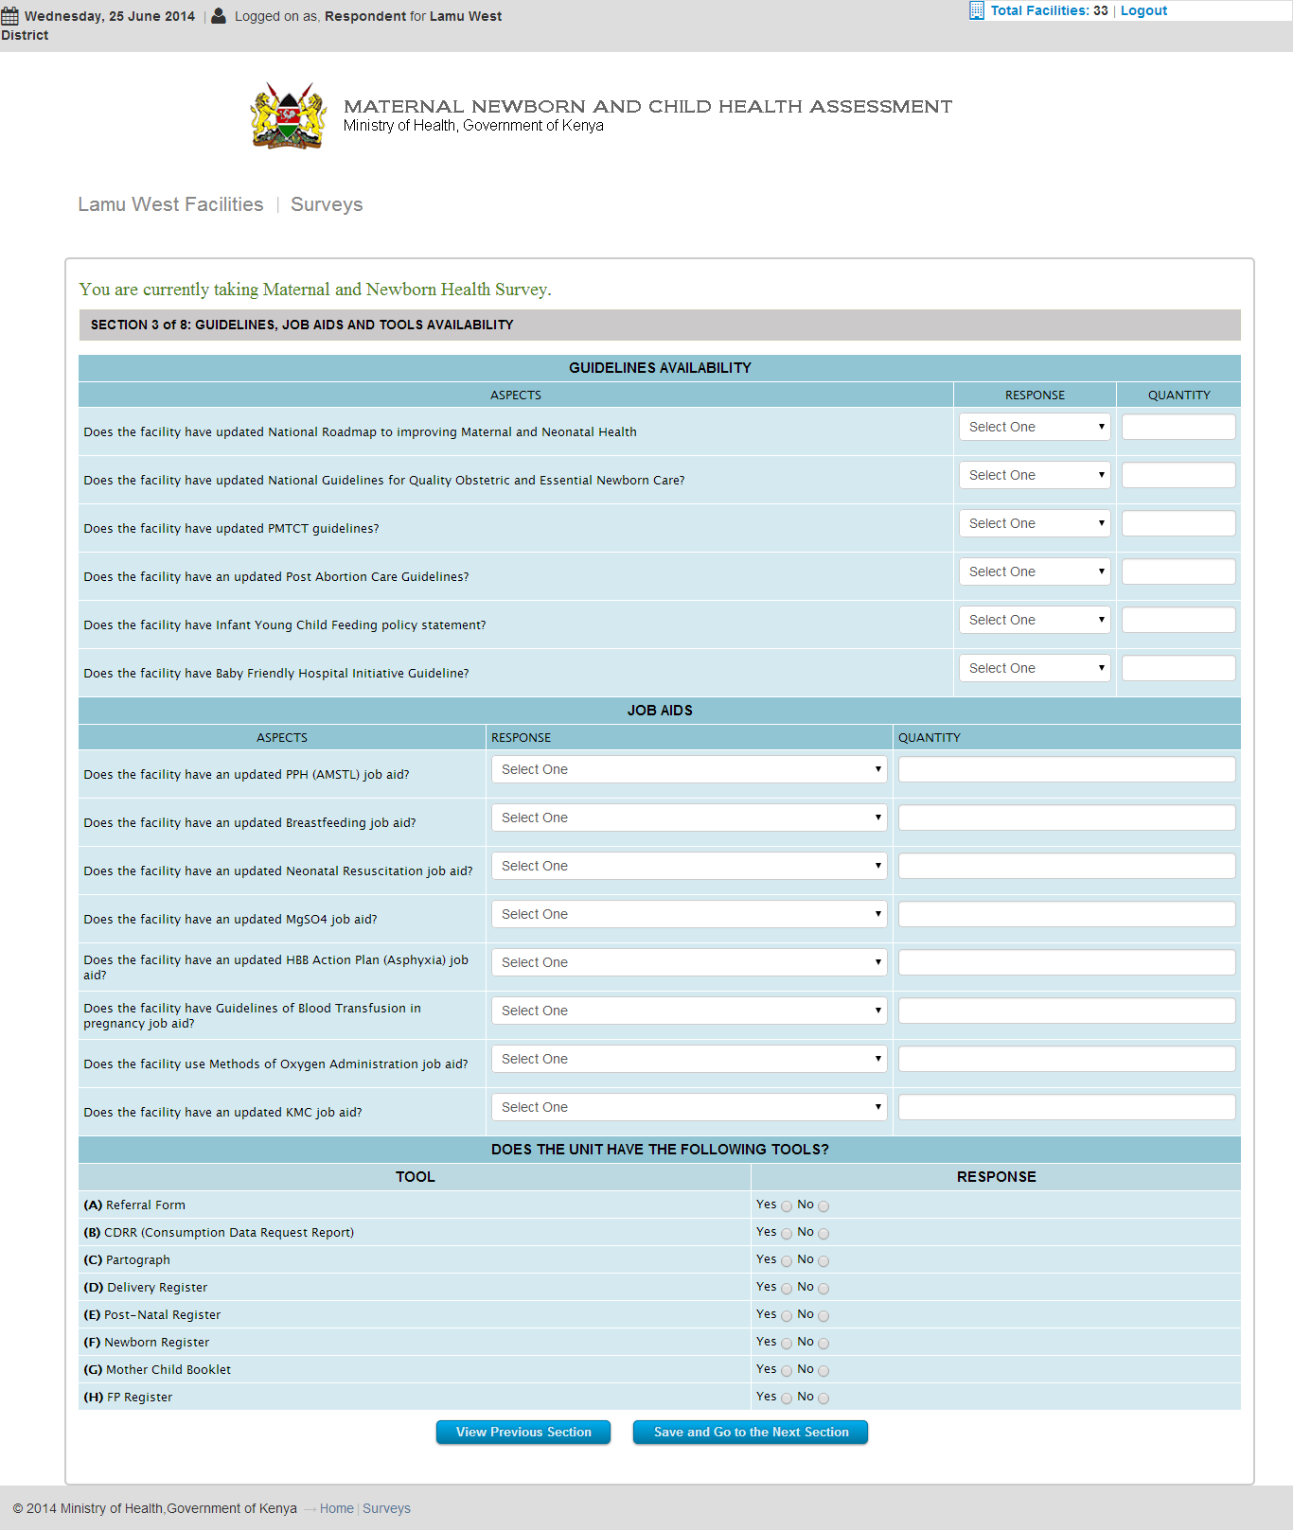

The figure above illustrates the third section of the survey form.

### Section 04 of 08 – STAFF TRAINING

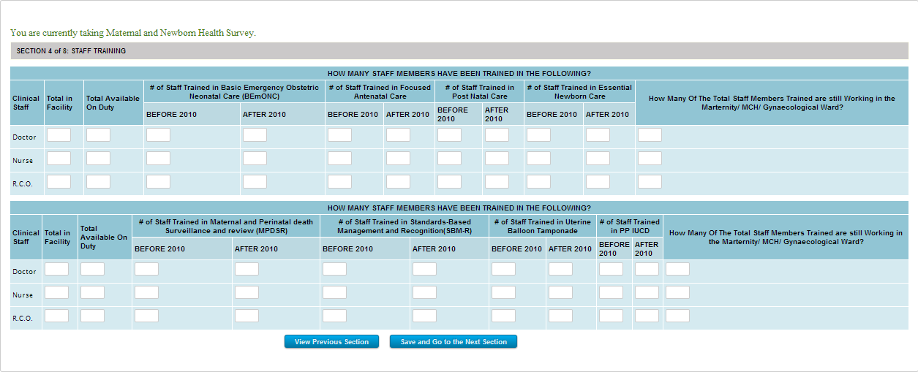

The figure above illustrates a part of the fourth section of the survey form.



**Click to go back**



Click this button if you would like to go back to the previous form section.



**Click to Proceed**



Click this button after filling in all the form details, to save the data and proceed to the next section.

### Section 05 of 08 – COMMODITY AVAILABILITY

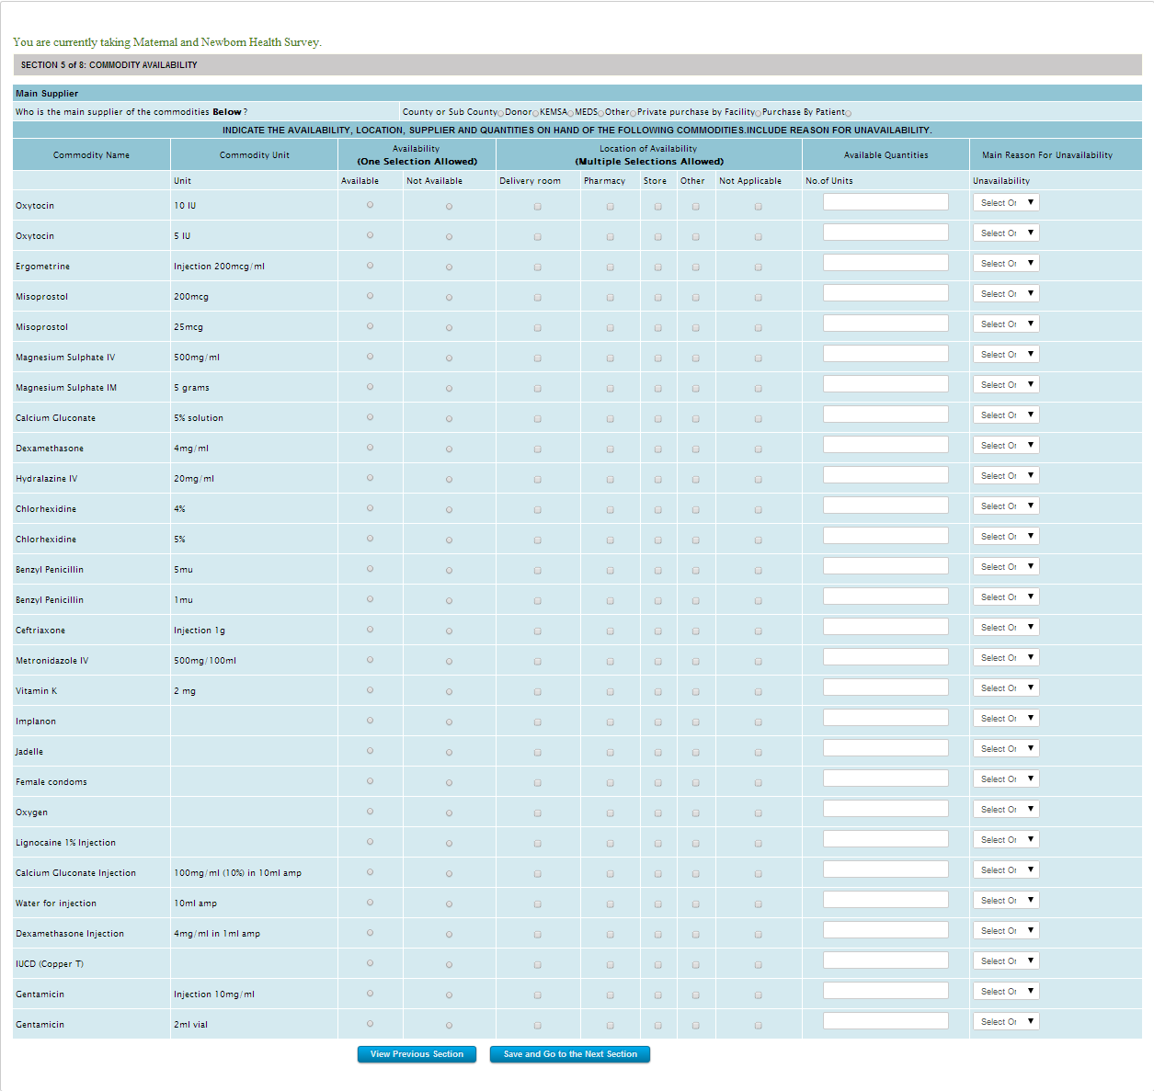

The figure above illustrates a part of the fifth section of the survey form.



**Click to go back**



Click this button if you would like to go back to the previous form section.



**Click to Proceed**



Click this button after filling in all the form details, to save the data and proceed to the next section.

### Section 06 of 08 – COMMODITY USAGE

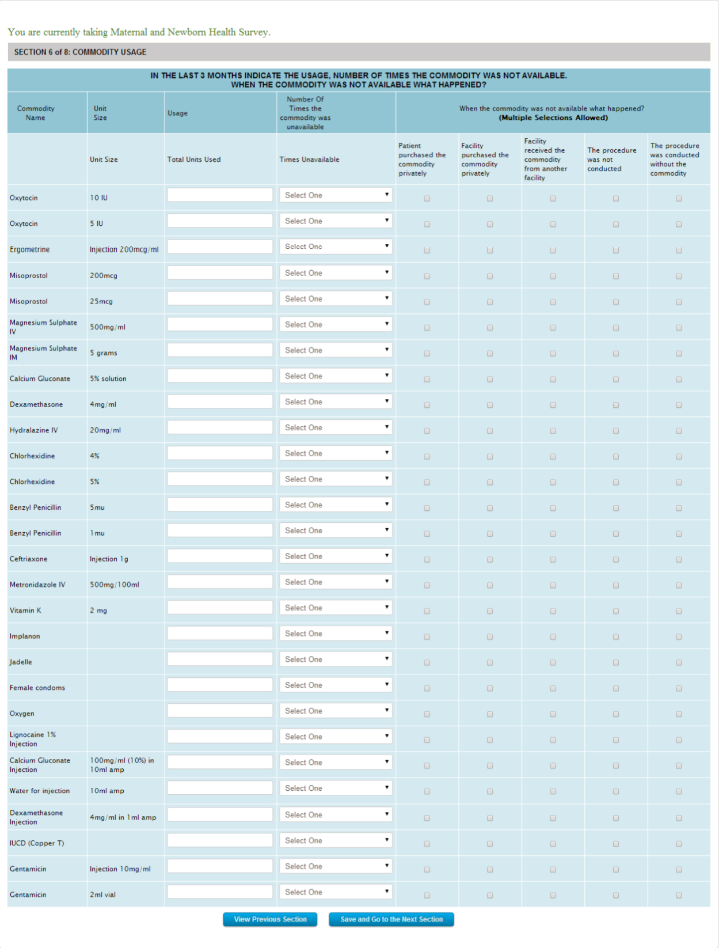

The figure above illustrates the sixth of the survey form.



**Click to go back**



Click this button if you would like to go back to the previous form section.



**Click to Proceed**



Click this button after filling in all the form details, to save the data and proceed to the next section.

### Section 07 of 08 – EQUIPMENT AVAILABILITY AND FUNCTIONALITY

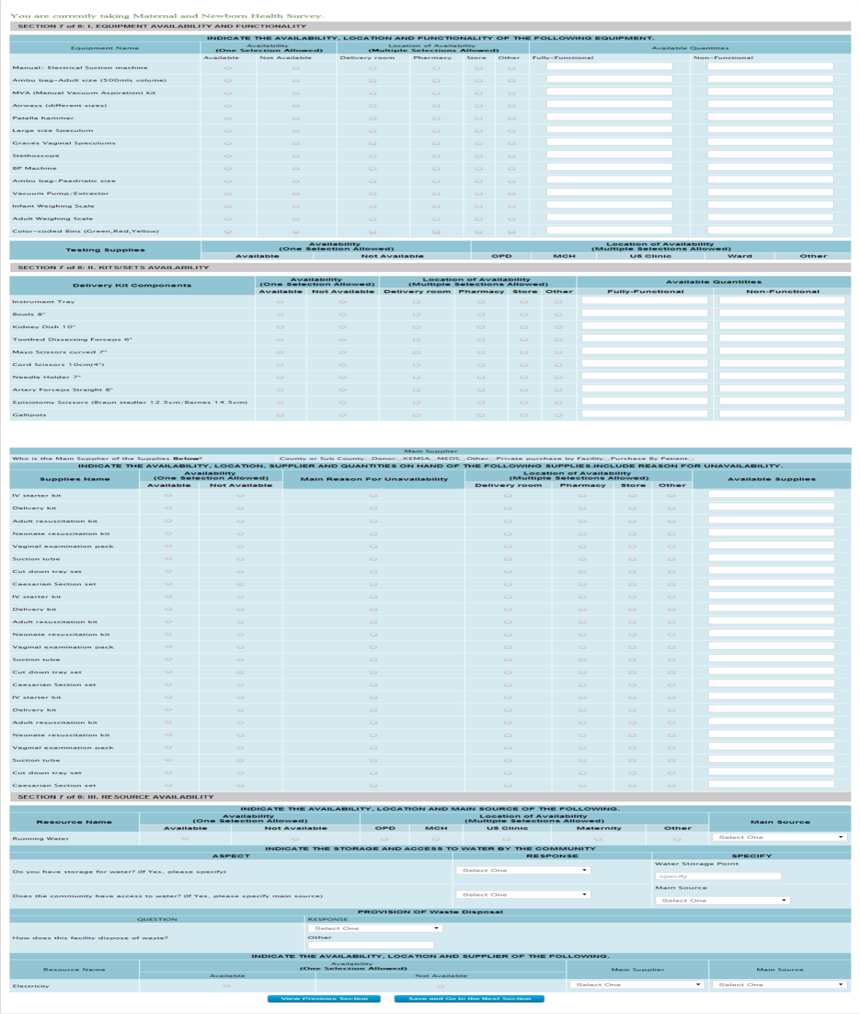

The figure above illustrates the seventh of the survey form.



**Click to go back**



Click this button if you would like to go back to the previous form section.



**Click to Proceed**



Click this button after filling in all the form details, to save the data and proceed to the next section.

### Section 08 of 08 – COMMUNITY STRATEGY

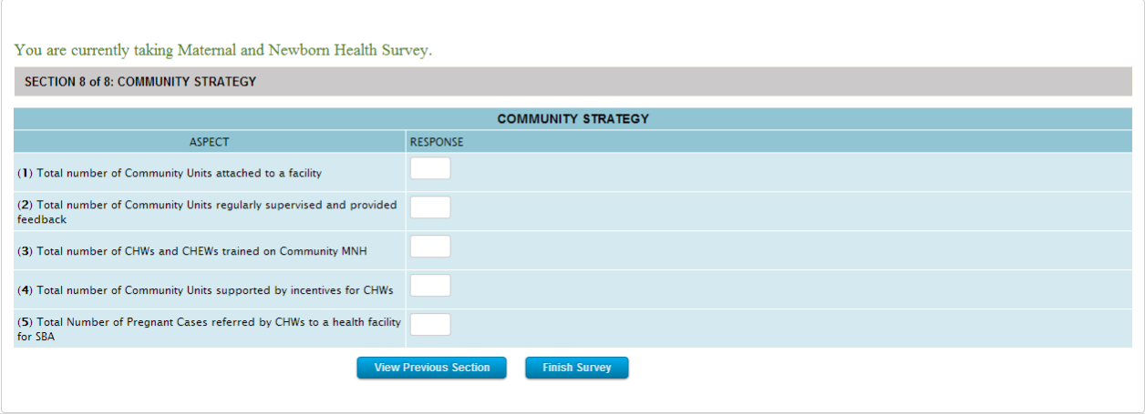The figure above illustrates the eighth of the survey form.



**Click to go back**



Click this button if you would like to go back to the previous form section.



**Click to Proceed**



Click this button after filling in all the form details, to save the data and finalize the survey.

# How to perform the Child Health Survey

This section shall outline, step by step, how to perform or insert data for the child health survey.

The following steps shall be observed in detail:

(To jump to a particular section, simply click on its title below)

How to perform a child health survey

* How to access the survey
* How to log in
* How to select a facility
* How to fill in the forms

##### How to access the survey

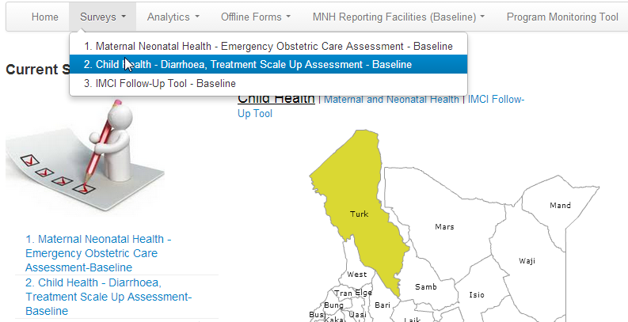

The figure above illustrates how to access the child health survey.



**Link 01**



Click this link to access the maternal neonatal health survey



**Link 02**

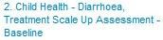

Click this link to access the maternal neonatal health survey

## How to Log in

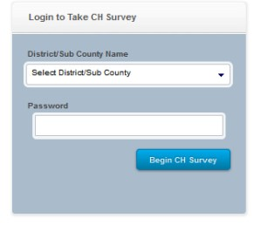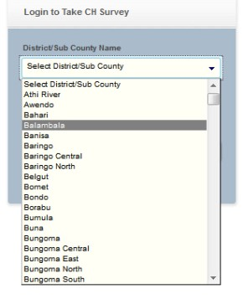

01. Once you access the survey, the above window 02.Select the region as indicated above shall appear

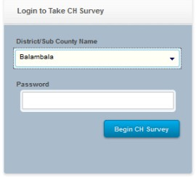 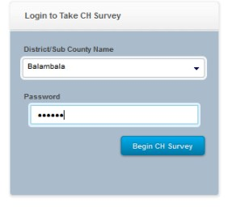

03. In the above example 'Balambala' is selected ******. Enter the password provided by your administrator and click on 'Begin MNH Survey'

##### How to select a facility

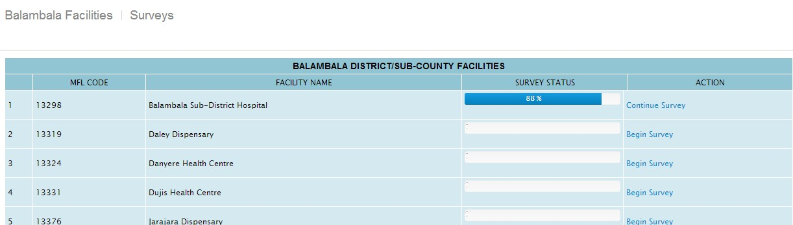

The figure above illustrates part of the list of facilities you are presented with, once you log in.

**Survey Status**



This indicates that the survey for this particular facility has been performed but not complete. It indicates that only 88% of the survey has been performed.

**Action**

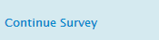

Clicking this link it loads the section the survey continues from. The user can then continue with the survey.

**Survey Status**

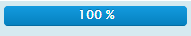

This indicates that the survey for this particular facility was performed and completed.

**Action**



This survey was completed therefore you shall not access the survey.

**Survey Status**

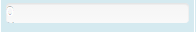

This survey indicates that is has not been performed in this facility.

**Action**



Clicking this link assumes that you have chosen then facility that it falls under and would like to insert survey data for that particular facility.

##### How to fill in the form

This section shall outline the various forms that collect survey data for the maternal health survey.

The form is divided into 9 parts or sections for simplification purposes.

### Section 01 of 09 – FACILITY INFORMATION

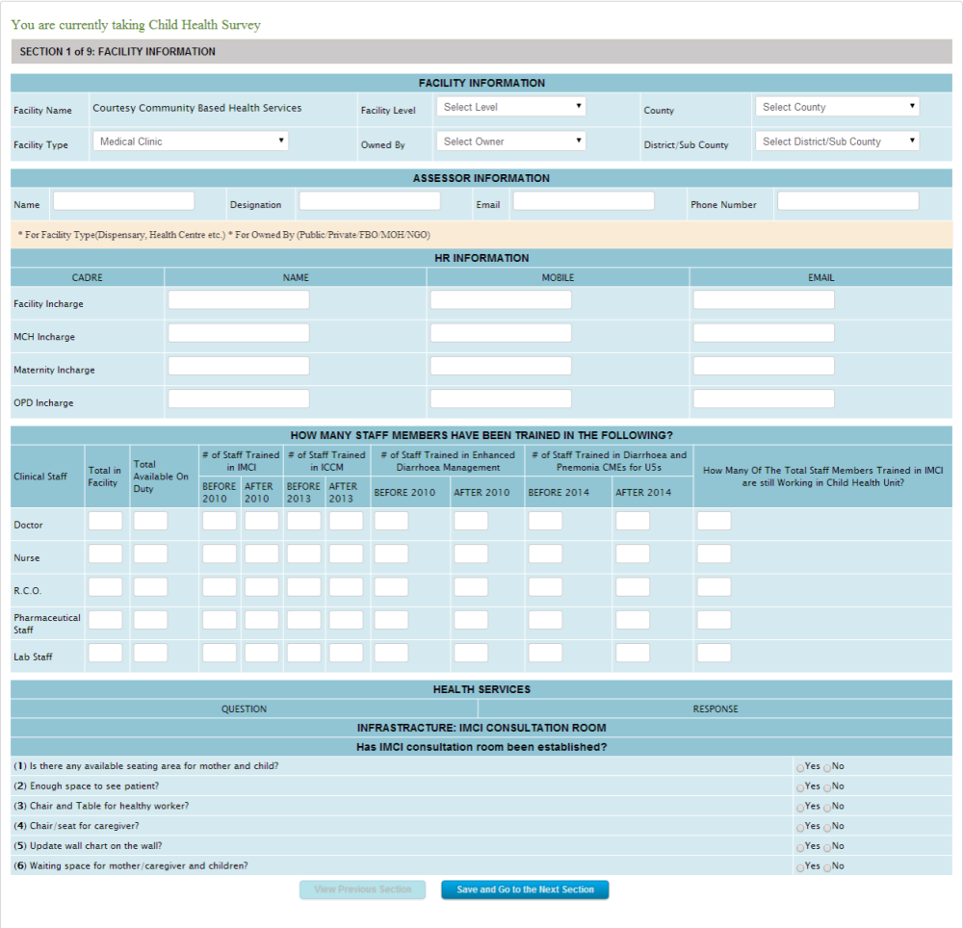

The figure above illustrates the first section of the survey form.



**Selected Facility**



Displays the facility location you selected when you logged into the system.

In this case, we selected 'Balambala' while logging in.



**Selected Survey**



Displays the survey that you are currently performing



**Form Section**



Simply indicates which section of the form you are currently filling.



**Click to Proceed**



Click this button after filling in all the form details, to save the data and proceed to the next section.

### Section 02 of 09 – GUIDELINES, JOB AIDS AND TOOLS

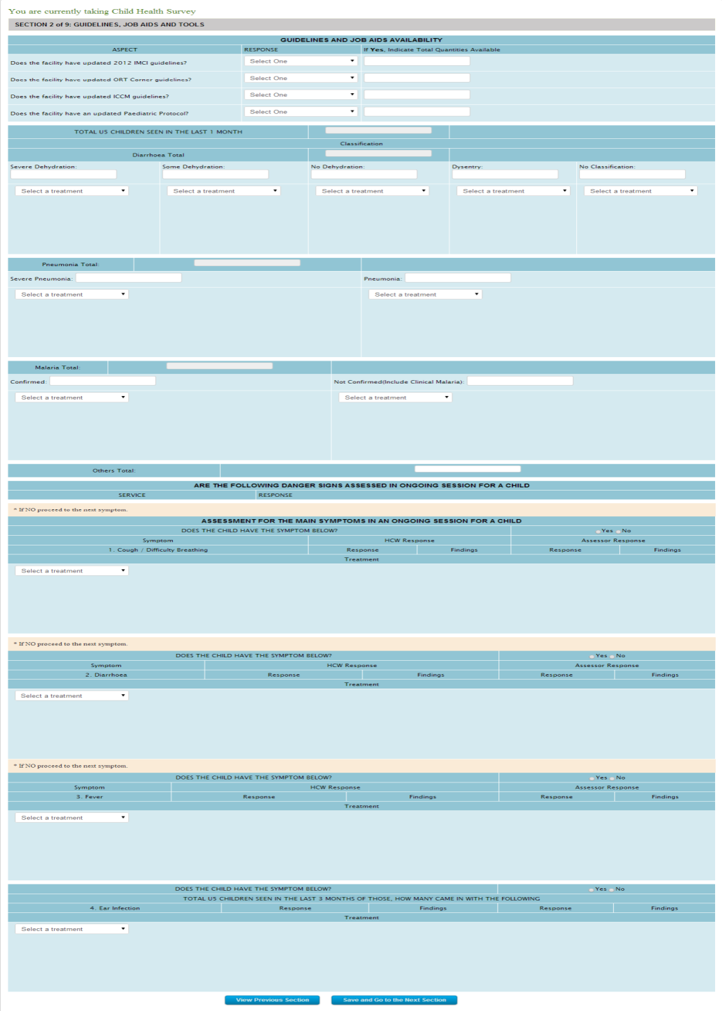

The figure above illustrates the second section of the survey form.



**Click to go back**



Click this button if you would like to go back to the previous form section.



**Click to Proceed**



Click this button after filling in all the form details, to save the data and proceed to the next section.

### Section 03 of 09 - SERVICE DELIVERY & QUALITY OF DIAGNOSIS

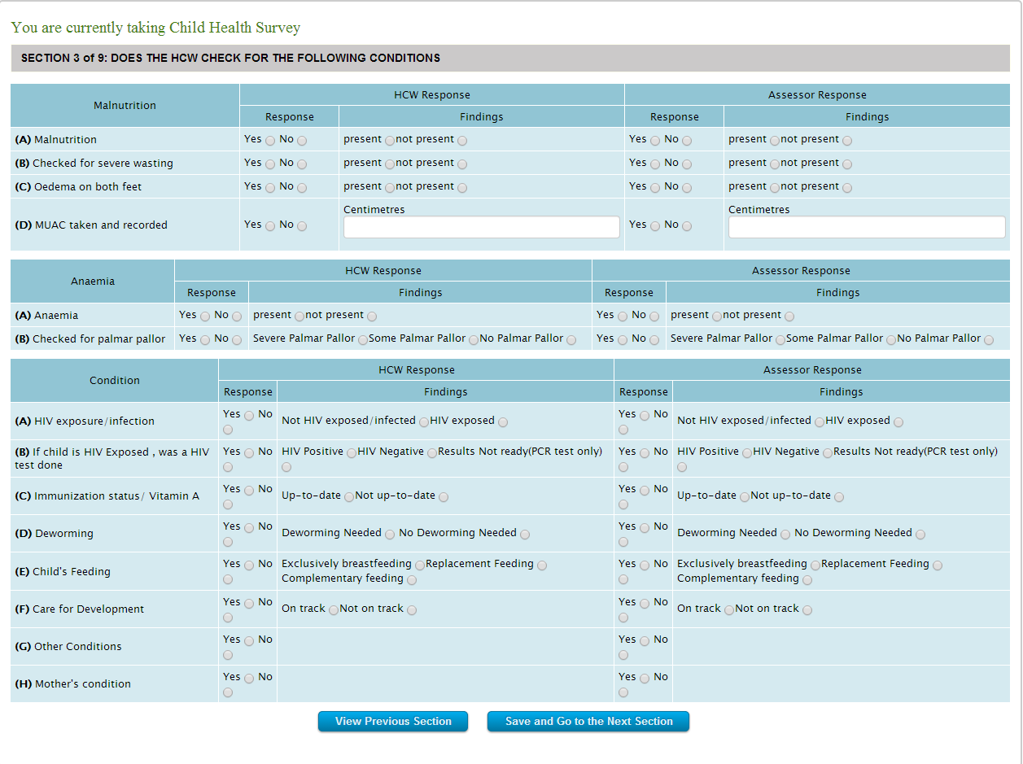

The figure above illustrates the third section of the survey form.



**Click to go back**



Click this button if you would like to go back to the previous form section.



**Click to Proceed**



Click this button after filling in all the form details, to save the data and proceed to the next section.

### Section 04 of 09 – COMMODITY AND BUNDLING AVAILABILITY

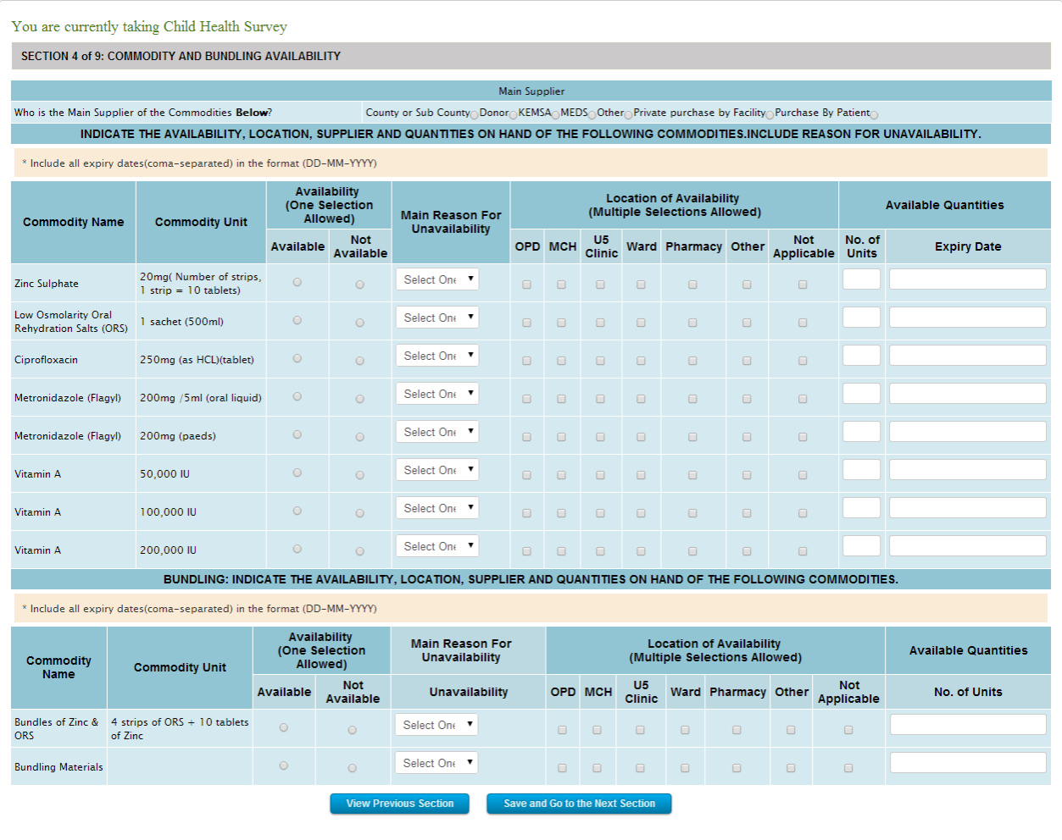

The figure above illustrates a part of the fourth section of the survey form.



**Click to go back**



Click this button if you would like to go back to the previous form section.



**Click to Proceed**



Click this button after filling in all the form details, to save the data and proceed to the next section.

### Section 05 of 09 – REVIEW OF RECORDS

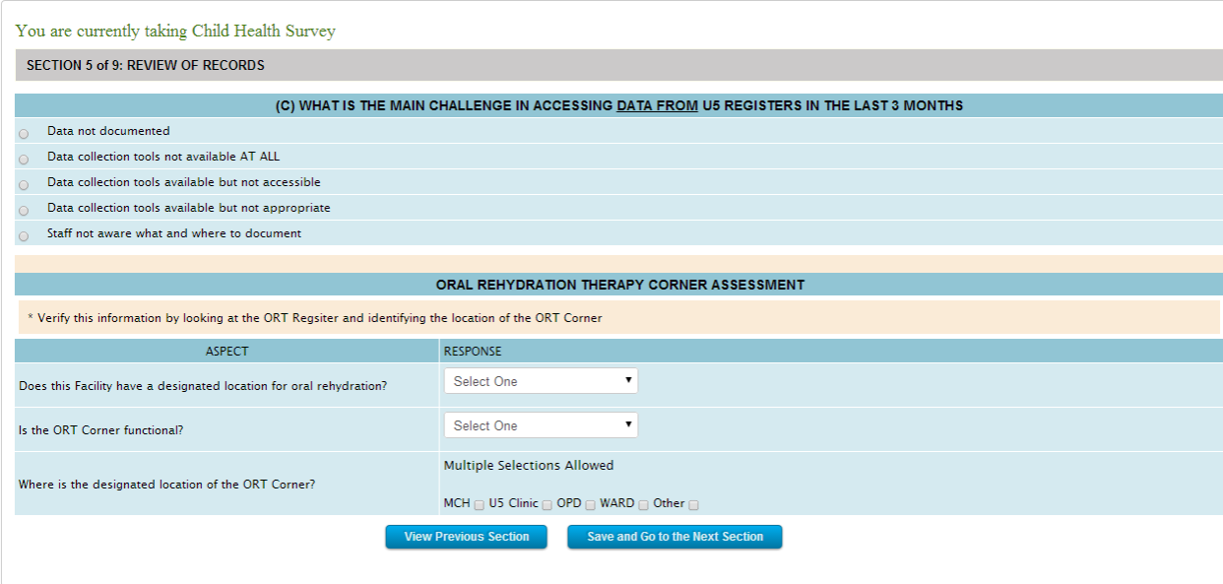

The figure above illustrates a part of the fifth section of the survey form.



**Click to go back**



Click this button if you would like to go back to the previous form section.



**Click to Proceed**



Click this button after filling in all the form details, to save the data and proceed to the next section.

### Section 06 of 09 – EQUIPMENT AVAILABILITY AND STATUS

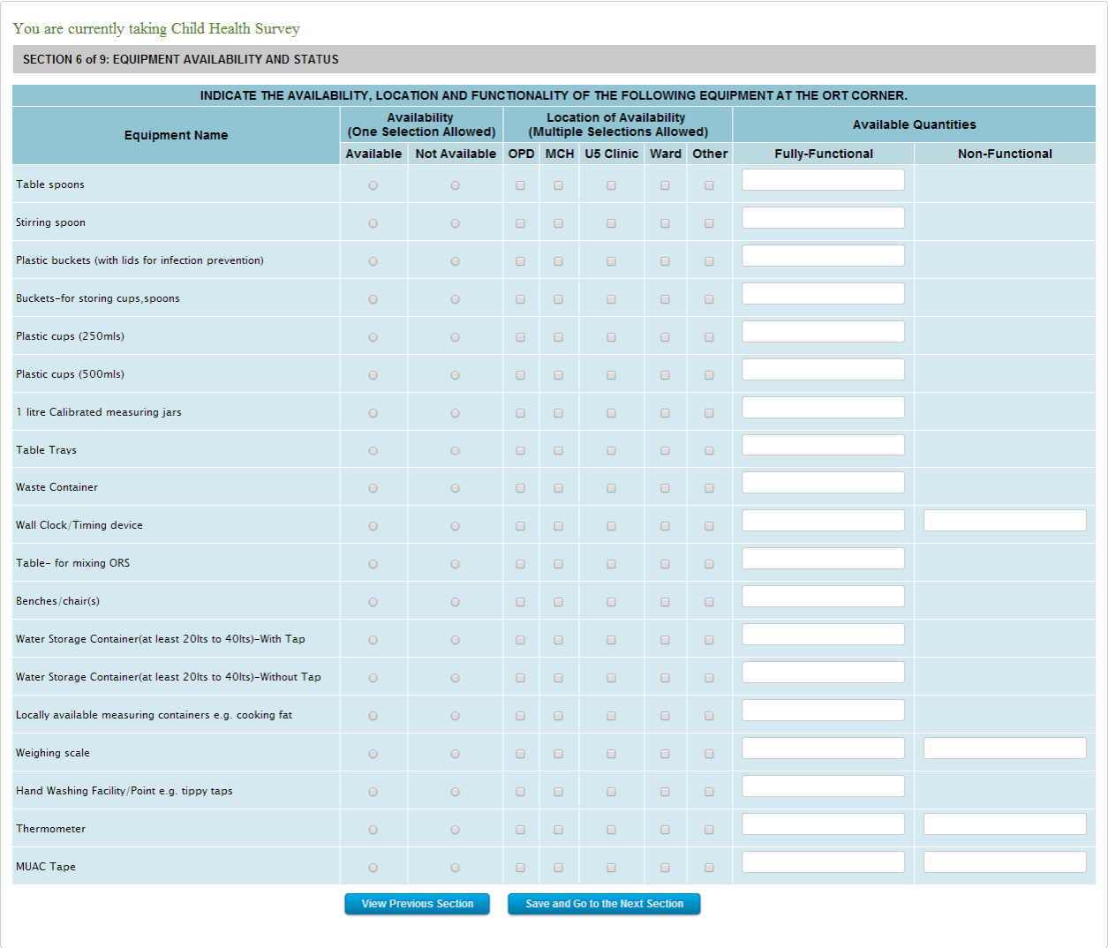

The figure above illustrates a part of the sixth section of the survey form.



**Click to go back**



Click this button if you would like to go back to the previous form section.



**Click to Proceed**



Click this button after filling in all the form details, to save the data and proceed to the next section.

Click this button after filling in all the form details, to save the data and finalize the survey.

### Section 07 of 09 – SUPPLIES AVAILABILITY

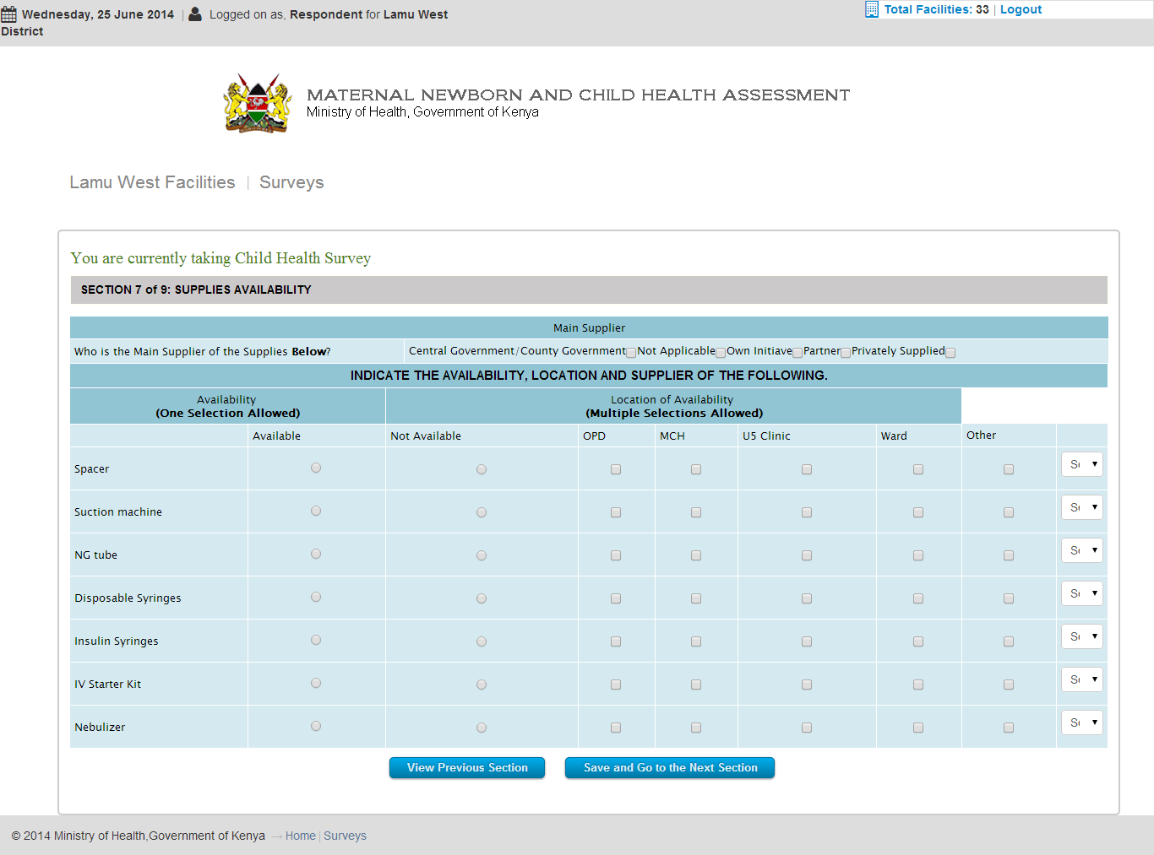

The figure above illustrates a part of the seventh section of the survey form.



**Click to go back**



Click this button if you would like to go back to the previous form section.



**Click to Proceed**



Click this button after filling in all the form details, to save the data and proceed to the next section.

### Section 08 of 09 – SUPPLIES AVAILABILITY

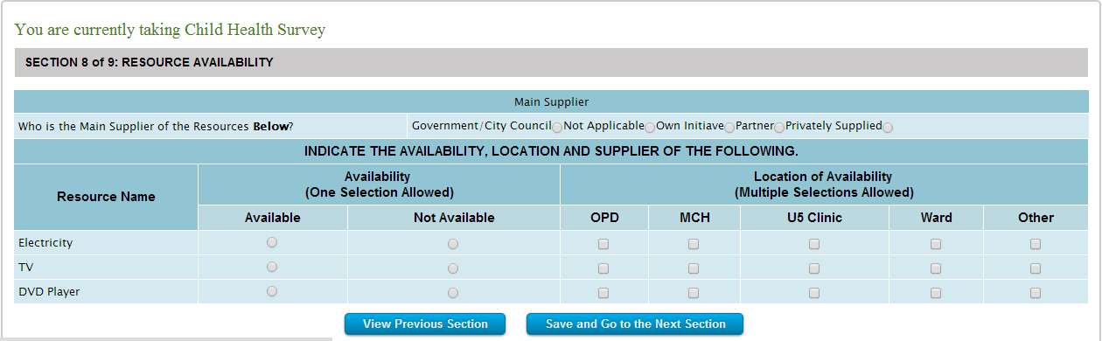

The figure above illustrates a part of the eighth section of the survey form.



**Click to go back**



Click this button if you would like to go back to the previous form section.



**Click to Proceed**



Click this button after filling in all the form details, to save the data and proceed to the next section.

### Section 09 of 09 – RESOURCE AVAILABILITY

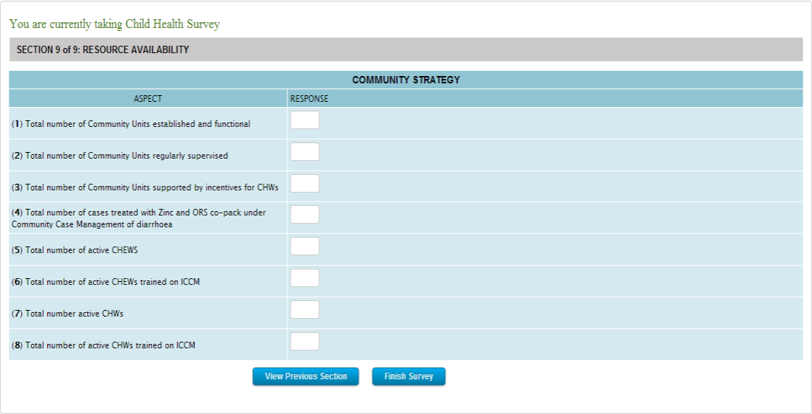

The figure above illustrates a part of the ninth section of the survey form.



**Click to go back**



Click this button if you would like to go back to the previous form section.



**Click to Proceed**



Click this button after filling in all the form details, to save the data and finalize the survey.

# How to perform the IMCI Follow-Up Tool Survey

This section shall outline, step by step, how to perform or insert data for the IMCI Follow-Up survey.

The following steps shall be observed in detail:

(To jump to a particular section, simply click on its title below)

How to perform an IMCI Follow-Up survey

* How to access the survey
* How to log in
* How to select a facility
* How to fill in the forms

##### How to access the survey

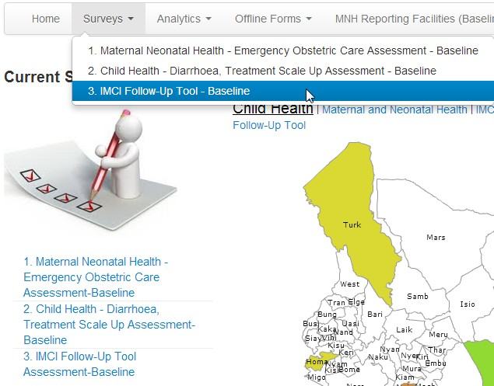

The figure above illustrates how to access the IMCI Follow-Up survey.



**Link 01**



Click this link to access the IMCI Follow-Up survey



**Link 02**

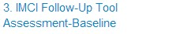

Click this link to access the IMCI Follow-Up survey

## How to Log in

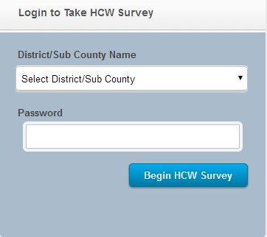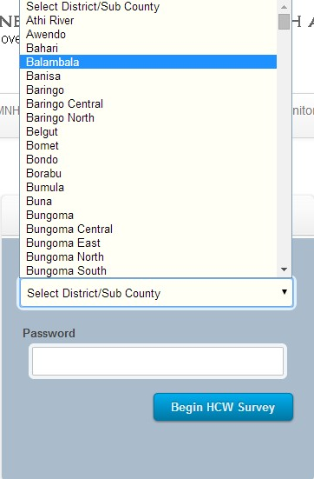

01. Once you access the survey, the above window 02.Select the region as indicated above shall appear

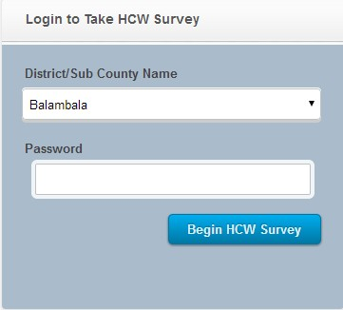 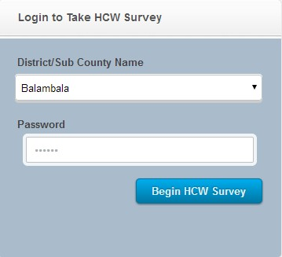

03. In the above example 'Balambala' is selected ******. Enter the password provided by your administrator and click on 'Begin HCW Survey'

##### How to select a facility



The figure above illustrates part of the list of facilities you are presented with, once you log in.

**Survey Status**



This indicates that the survey for this particular facility has been performed but not complete. It indicates that only 88% of the survey has been performed.

**Action**



Clicking this link it loads the section the survey continues from. The user can then continue with the survey.

**Survey Status**



This indicates that the survey for this particular facility was performed and completed.

**Action**



This survey was completed therefore you shall not access the survey.

**Survey Status**



This survey indicates that is has not been performed in this facility.

**Action**



Clicking this link assumes that you have chosen then facility that it falls under and would like to insert survey data for that particular facility.

##### How to fill in the form

This section shall outline the various forms that collect survey data for the maternal health survey.

The form is divided into 9 parts or sections for simplification purposes.

### Section 01 of 05 – FACILITY INFORMATION

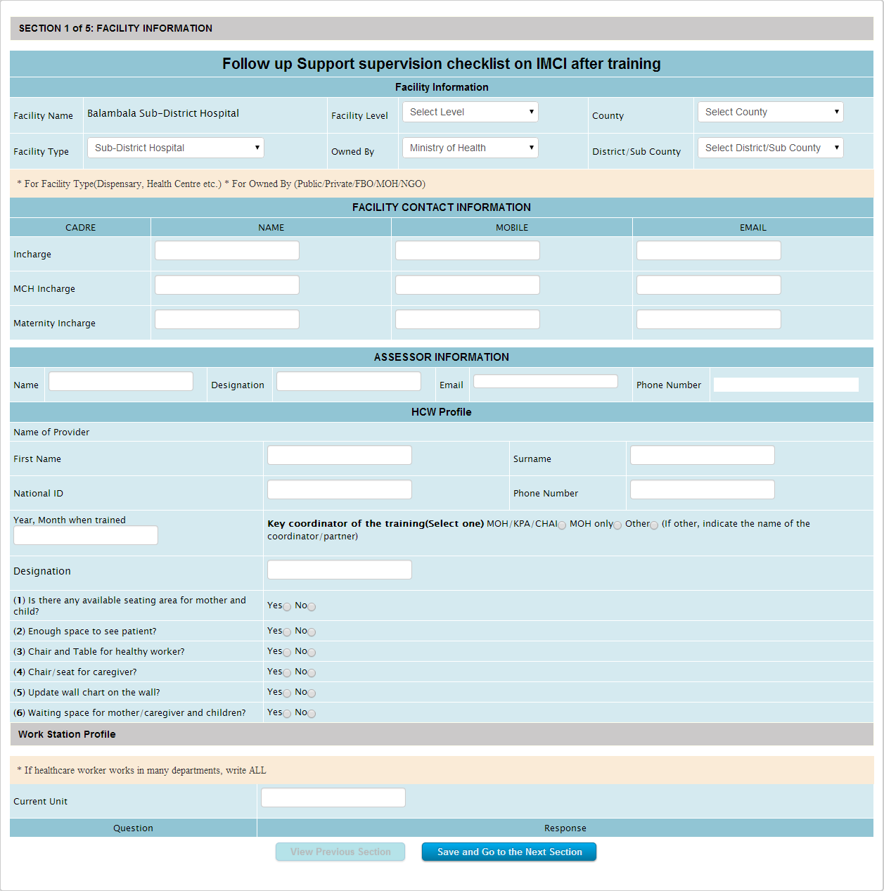

The figure above illustrates the first section of the survey form.



**Selected Facility**



Displays the facility location you selected when you logged into the system.

In this case, we selected 'Balambala' while logging in.



**Selected Survey**



Displays the survey that you are currently performing



**Form Section**



Simply indicates which section of the form you are currently filling.



**Click to Proceed**



Click this button after filling in all the form details, to save the data and proceed to the next section.

### Section 02 of 05 – OBSERVATION OF CASE MANAGEMENT

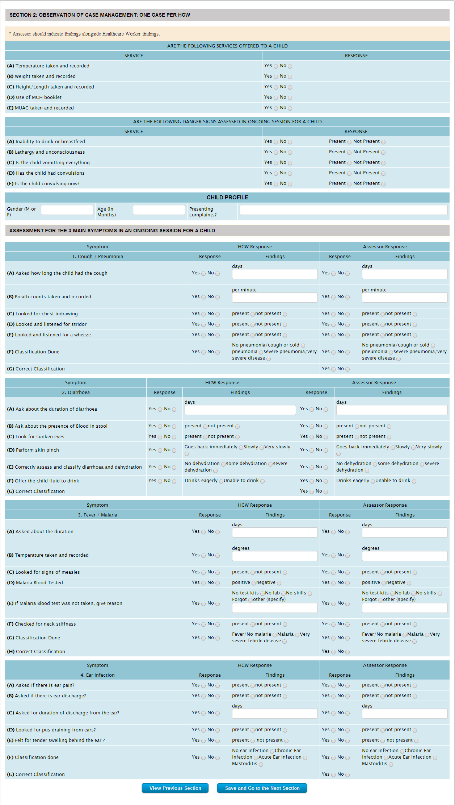

The figure above illustrates the second section of the survey form.



**Click to go back**



Click this button if you would like to go back to the previous form section.



**Click to Proceed**



Click this button after filling in all the form details, to save the data and proceed to the next section.

### Section 03 of 05 – DOES THE HCW CHECK FOR THE FOLLOWING

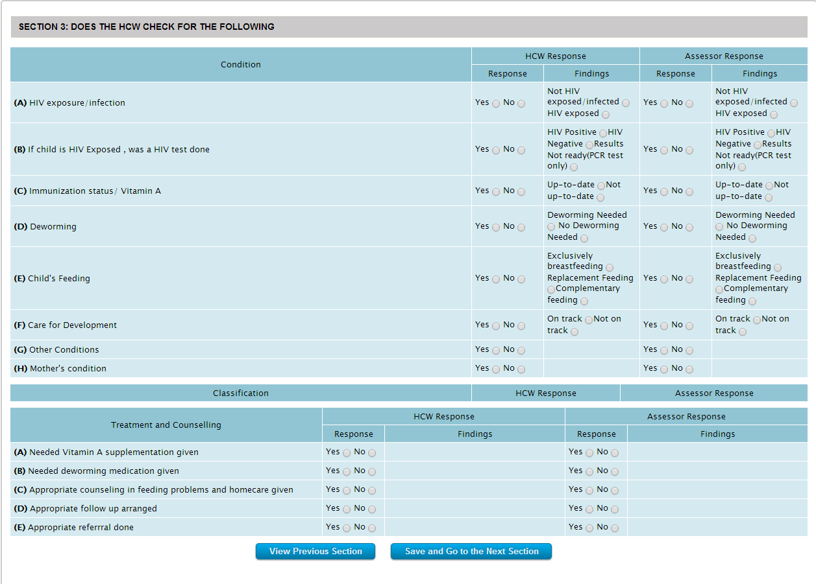

The figure above illustrates the third section of the survey form.



**Click to go back**



Click this button if you would like to go back to the previous form section.



**Click to Proceed**



Click this button after filling in all the form details, to save the data and proceed to the next section.

### Section 04 of 05 – CONSULTATION OBSERVATION

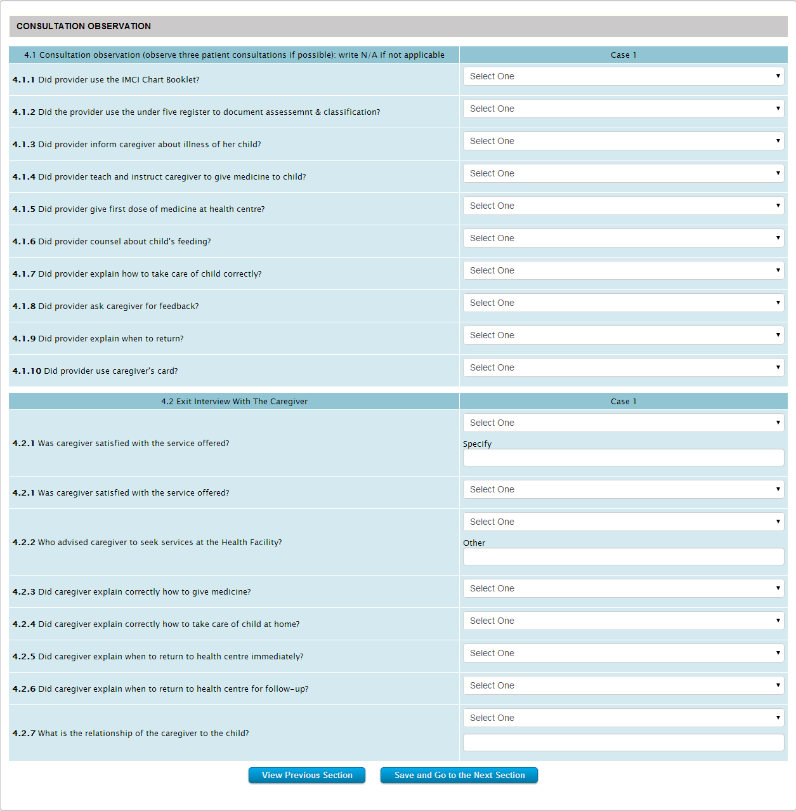

The figure above illustrates a part of the fourth section of the survey form.



**Click to go back**



Click this button if you would like to go back to the previous form section.



**Click to Proceed**



Click this button after filling in all the form details, to save the data and proceed to the next section.

### Section 05 of 05 – ASSESSMENT OUTCOME

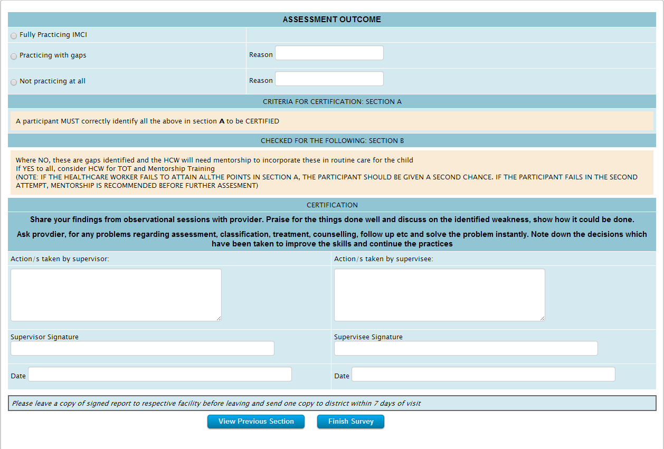

The figure above illustrates a part of the fifth section of the survey form.



**Click to go back**



Click this button if you would like to go back to the previous form section.



**Click to Proceed**



Click this button after filling in all the form details, to save the data and finalize the survey.

# How to Analyze a Survey

This section shall guide you, step by step, on how to analyze the results of a survey for a particular region.

We shall review the following, step by step, and in detail:

#### How to Access the Analytics Section

This section shall explain how to gain access to the analytics section of the system.

Unlike the Survey section, the Analytics section does not require the user to be logged in.

The following shall be reviewed in detail:

(To jump to a particular section, simply click on its title below)

01. How to access the Maternal Neonatal Health Analysis

02. How to access the Child Health Analysis

03. How to access the IMCI Follow-Up Tool Analysis

## How to access the Maternal Health Analysis

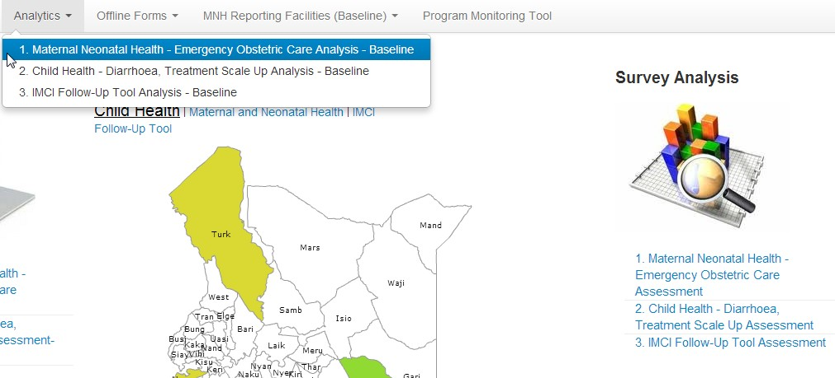

The figure above illustrates how to access the maternal neonatal health survey analysis.



**Link 01**

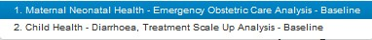

Click this link to access the maternal neonatal health survey analysis.



**Link 02**

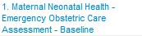

Click this link to access the maternal neonatal health survey analysis.

## How to access the Child Health analysis

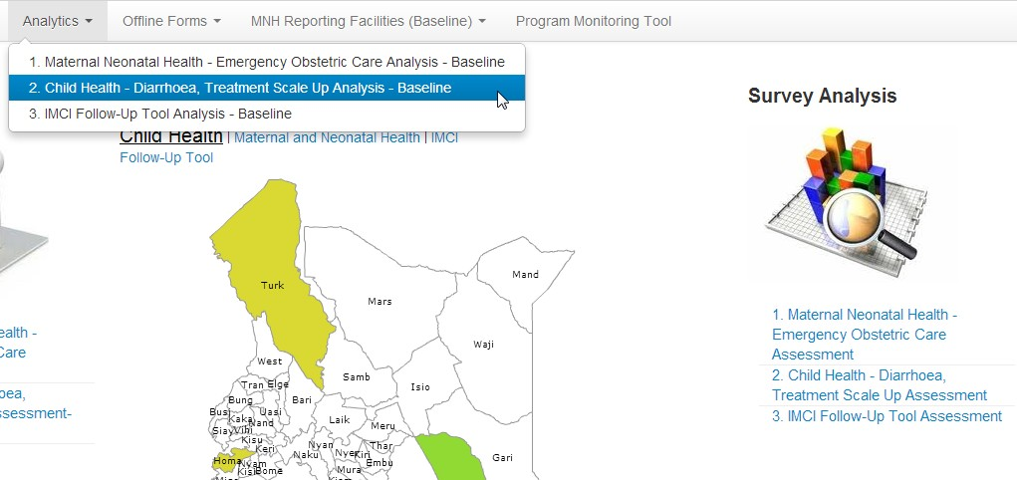

The figure above illustrates how to access the child health survey analysis.



**Link 01**

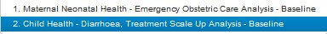

Click this link to access the child health survey analysis.



**Link 02**

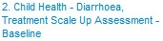

Click this link to access the child health survey analysis.

## How to access the IMCI Follow-Up Tool analysis

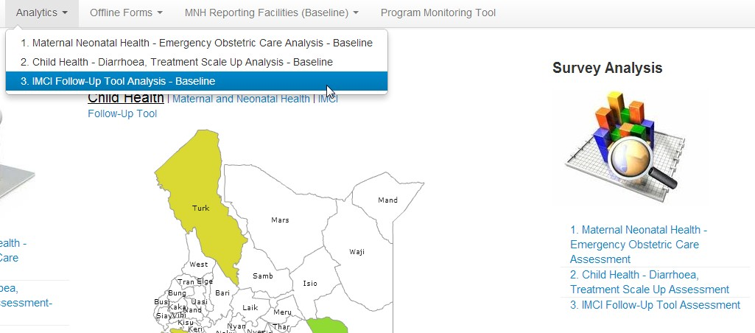

The figure above illustrates how to access the IMCI Follow-Up survey analysis.



**Link 01**

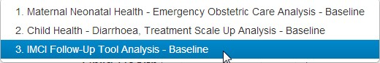

Click this link to access the IMCI Follow-Up survey analysis.



**Link 02**

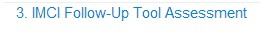

Click this link to access the IMCI Follow-Up survey analysis.

# How to Analyze a County

This section shall guide you, step by step, on how to analyze the results of a survey for a particular county.

We shall review the following, step by step, and in detail:

## Analytics Summary for an Unselected County

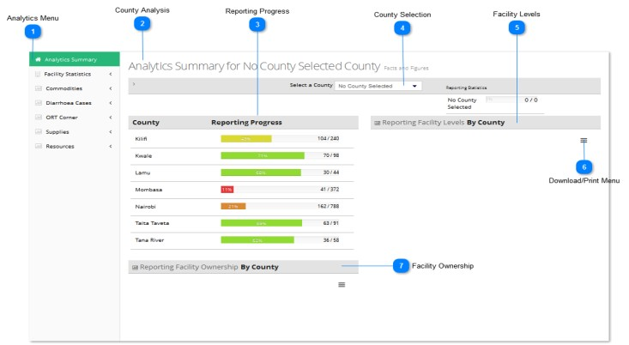

The figure above illustrates the analytics page with no county selected.



**Analytics Menu**

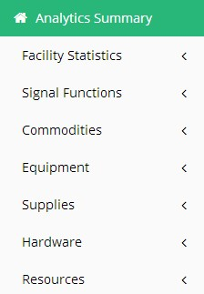

This is the analytics menu.

It displays the current factor under analysis in that particular county.

Clicking on any of the menu items shall result in the county analytics for that selected criteria.

In this case no criteria (menu item) are selected therefore all that is shown is a summary of the reporting progress.



**County Analysis**



This indicates the particular county currently being analyzed.

In this case, no county has been selected; therefore no county specific analytics is displayed.



**Reporting Progress**

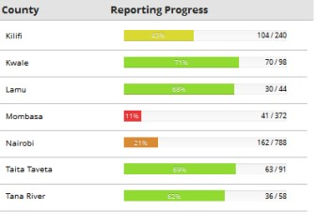

This section shows the reporting progress in the entire region (country).

Therefore the counties that appear on this chart are those in which surveys are either ongoing or already complete.

The number appearing on the right indicates the progress in terms of, number of facilities already surveyed out of the total number of facilities present in that county.

The color coded progress bar is simply an indication of the same but in percentage.



**County Selection**



This is the county selection menu.

The counties that shall appear in this menu are for those that already have undergoing surveys or complete surveys.

Counties in which the survey process is yet to begin shall not appear in this menu.



**Facility Levels**



There are 3 facility levels within a county:

* Facilities at County level
* Facilities at Constituency level
* Facilities at Ward level

This chart shows a bar graph, in percentage, of the facility reporting levels out of the total reports (surveys) collected.

A detailed explanation of this using an example can be found here.



**Download/Print Menu**

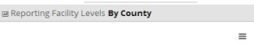

Clicking on the icon at the bottom right hand of the above figure shall provide a menu item allowing you to download or print an image of the current chart.

This icon can be found on every chart within the analysis.



**Facility Ownership**



This section illustrates medical facility ownership per county.

A facility can be owned by either of the following:

* MOH - The Ministry of Health
* Non-Governmental Organizations
* FBO - Faith Based Organizations
* Community
* Private

## Analytics Summary for a Selected County

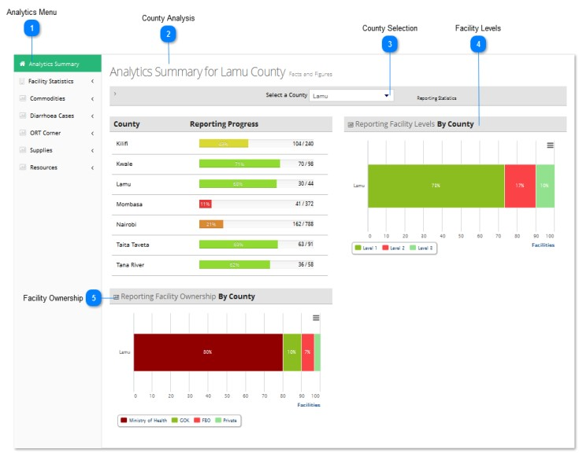

The figure above illustrates the analytics page with a county selected.



**Analytics Menu**



This is the analytics menu.

It displays the current factor under analysis in the selected county.

Clicking on any of the menu items shall result in the county analytics for that selected criteria.

In this case, no criteria (menu item) is selected, therefore an analytics summary of Lamu County shall be shown.



**County Analysis**



This indicates the particular county currently being analyzed.

In this case, Lamu County has been selected; therefore the charts below specifically display Lamu county analytics.



**County Selection**



This is the county selection menu.

The counties that shall appear in this menu are for those that already have undergoing surveys or complete surveys. In this case Lamu County is selected, therefore the charts that follow display information relevant to Lamu County.



**Facility Levels**

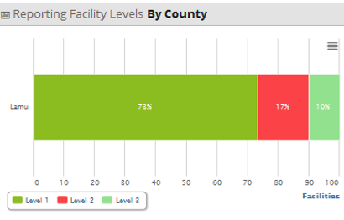

There are 3 facility levels within a county:

* Facilities at County level
* Facilities at Constituency level
* Facilities at Ward level

This chart shows a bar graph, in percentage, of the facility reporting levels out of the total reports (surveys) collected.

In this particular case, Lamu County is selected, therefore:

* 73% of the total reports(surveys) so far, are from level 1 facilities
* 17% of the total reports(surveys) so far, are from level 2 facilities
* 10% of the total reports(surveys) so far, are from level 3 facilities



**Facility Ownership**

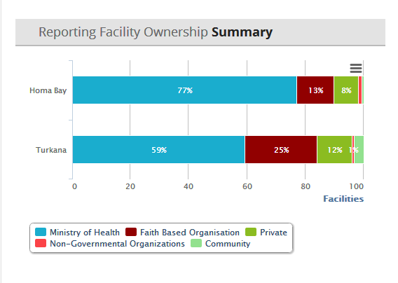

This section illustrates medical facility ownership per county.

A facility can be owned by either of the following:

* MOH - The Ministry of Health
* Non-Governmental Organizations
* FBO - Faith Based Organizations
* Community
* Private

# MNH Analytics

This section shall focus on the 'facility analytics' sub-menu of the 'analytics' menu.

## FACILITY STATISTICS

* Nurses Deployed
* Beds in Facility
* Services
* Health Facility Management
* Deliveries
* HIV Testing
* Job Aids
* Guidelines Availability
* Community Strategy
* Staff Training

### Nurses Deployed

### Beds in Facility

### Services

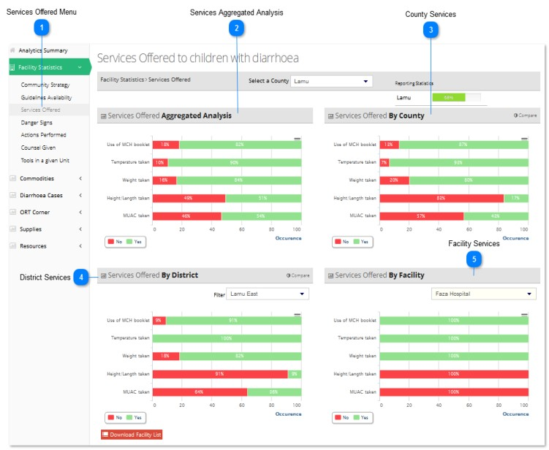

The figure above illustrates the 'services offered' analytics for Lamu County



**Services Offered Menu**

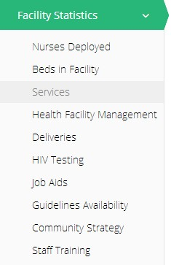

'Services Offered' is a sub-menu of the 'Facility Statistics' menu.

To access items under the 'Facility Statistics' menu, click on 'Services Offered' and the submenu shall be revealed.

In this case, 'Services Offered' of Lamu County has been selected and the various charts have been displayed.



**Services Aggregated Analysis**

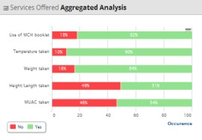

This is an aggregated analysis of the services offered in facilities across the entire region (all counties included).

For instance, in the above analysis;

* Use of MCH booklet is present in 82% of the total facilities surveyed so far in the entire region
* Temperature taking is practiced in 90% of the total facilities surveyed so far in the entire region
* Weight taking is practiced in 84% of the total facilities surveyed so far in the entire region
* Height Length taking is practiced in 57% of the total facilities surveyed so far in the entire region
* MUAC taking is practiced in 54% of the total facilities surveyed so far in the entire region



**County Services**

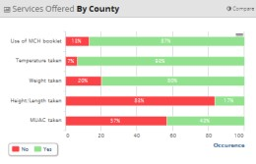

This represents the services offered aggregated analysis of all the facilities in a specific county. In this case, all facilities located in Lamu county.

For instance, in the above analysis;

* Use of MCH booklet is present in 87% of the total facilities surveyed so far in the entire county
* Temperature taking is practiced in 92% of the total facilities surveyed so far in the entire county
* Weight taking is practiced in 82% of the total facilities surveyed so far in the entire county
* Height Length taking is practiced in 17% of the total facilities surveyed so far in the entire county
* MUAC taking is practiced in 42% of the total facilities surveyed so far in the entire county



**District Services**

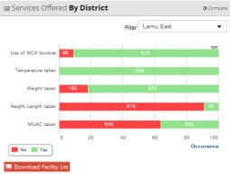

This represents the services offered aggregated analysis of the facilities in a specific district in the selected county.

After selecting the county above, you need to select a specific region within the county.

In this case, only medical facilities located in Lamu East District in Lamu county.

For instance, in the above analysis;

* Use of MCH booklet is present in 91% of the total facilities surveyed so far in Lamu East
* Temperature taking is practiced in 100% of the total facilities surveyed so far in Lamu East
* Weight taking is practiced in 82% of the total facilities surveyed so far in Lamu East
* Height Length taking is practiced in 9% of the total facilities surveyed so far in Lamu East
* MUAC taking is practiced in 36% of the total facilities surveyed so far in Lamu East



**Facility Services**

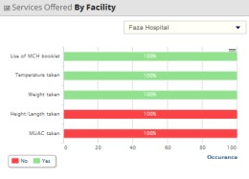

This represents the services offered analysis of a specific facility in a particular district in the selected county.

After selecting the district/region above, you need to select a specific facility within that region.

In this case, Feza Hospital in Lamu East District in Lamu county

For instance, in the above analysis;

* Use of MCH booklet is practiced in Feza Hospital in Lamu East
* Temperature taking is practiced in Feza Hospital in Lamu East
* Weight taking is practiced in Feza Hospital in Lamu East
* Height Length taking is absent in Feza Hospital in Lamu East
* MUAC taking is absent in Feza Hospital in Lamu East

### Health Facility Management

### Deliveries

### HIV Testing

### Job Aids

### Guidelines Availability

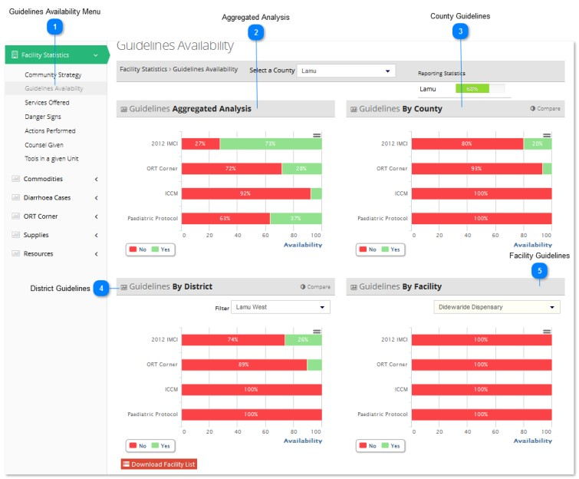

The figure above illustrates the 'guidelines availability' analytics for Lamu County



**Guidelines Availability Menu**

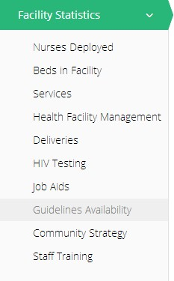

'Guideline Availability' is a sub-menu of the 'Facility Statistics' menu.

To access items under the 'Facility Statistics' menu, click on 'Facility Statistics' and the submenu shall be revealed.

In this case, 'Guideline Availability' of Lamu County has been selected and the various charts have been displayed.



**Aggregated Analysis**

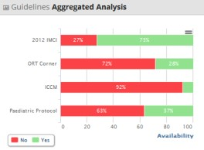

This is an aggregated analysis of the guidelines availability across the entire region (all counties included).

For instance, in the above analysis;

* 2012 IMCI is present in 73% of the total facilities surveyed so far in the entire region
* ORT corners are present in 28% of the total facilities surveyed so far in the entire region
* ICCM is present in 8% of the total facilities surveyed so far in the entire region
* Pediatric Protocol is present in 37% of the total facilities surveyed so far in the entire region



**County Guidelines**

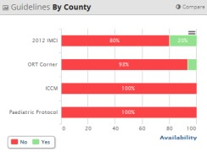

This represents the guidelines availability aggregated analysis of all the facilities in a specific county. In this case, all facilities located in Lamu county.

For instance, in the above analysis;

* 2012 IMCI is present in 20% of the total facilities surveyed so far in Lamu county
* ORT corners are present in 7% of the total facilities surveyed so far in Lamu county
* ICCM is present in none of the total facilities surveyed so far in Lamu county
* Paediatric Protocol is present in none of the total facilities surveyed so far in Lamu county



**District Guidelines**

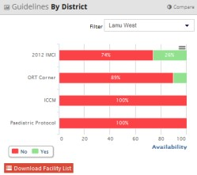

This represents the guidelines availability aggregated analysis of the facilities in a specific district in the selected county.

After selecting the county above, you need to select a specific region within the county.

In this case, only medical facilities located in Lamu West District in Lamu county.

For instance, in the above analysis;

* 2012 IMCI is present in 26% of the total facilities surveyed so far in Lamu West District
* ORT corners are present in 11% of the total facilities surveyed so far in Lamu West District
* ICCM is present in none of the total facilities surveyed so far in Lamu West District
* Paediatric Protocol is present in none of the total facilities surveyed so far in Lamu West District



**Facility Guidelines**

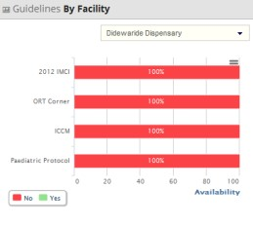

This represents the guidelines availability analysis of a specific facility in a particular district in the selected county.

After selecting the district/region above, you need to select a specific facility within that region.

In this case, Didewaride Dispensary in Lamu West District in Lamu county

For instance, in the above analysis;

* 2012 IMCI is absent in Didewaride Dispensary in Lamu West District
* ORT corners are absent in Didewaride Dispensary in Lamu West District
* ICCM is absent in Didewaride Dispensary in Lamu West District
* Paediatric Protocol is absent in Didewaride Dispensary in Lamu West District

### Community Strategy

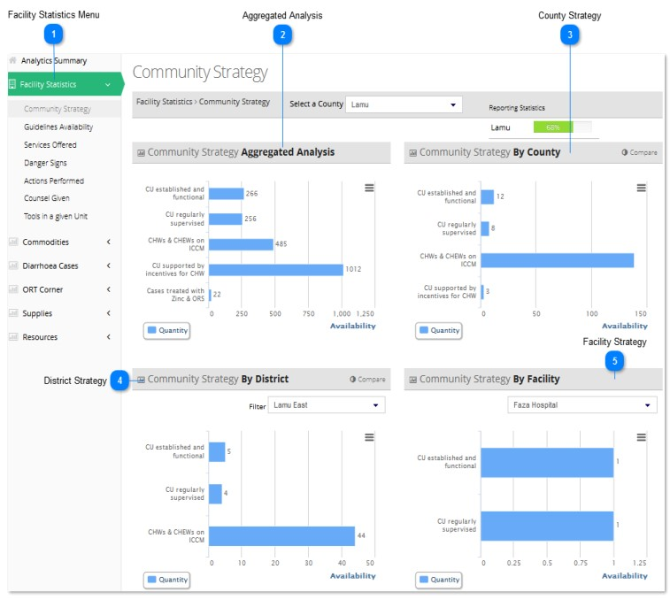

The figure above illustrates the community strategy analytics for Lamu County.



**Facility Statistics Menu**

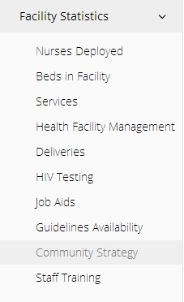

'Facility Statistics' is a sub-menu of the analytics menu.

To access items under the 'Facility Statistics' menu, click on 'Facility Statistics' and the submenu shall be revealed.

In this case, 'Community Strategy' of Lamu County has been selected and the various charts have been displayed.



**Aggregated Analysis**

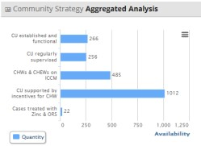

This is an aggregated analysis of the implementation of community strategy across the entire region (country).

For instance, in the above analysis;

* CU is established and functional in 266 facilities surveyed so far
* CU is regularly supervised in 256 facilities surveyed so far
* CHWs & CHEWs on ICCM in 485 facilities surveyed so far
* CU is supported by incentives for CHW in 1012 facilities surveyed so far
* Cases treated with Zinc & ORS are 22 in the facilities surveyed so far



**County Strategy**

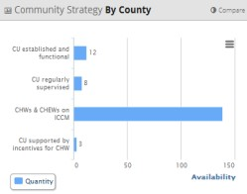

This represents the community strategy aggregated analysis of all the facilities in a specific county. In this case, all facilities located in Lamu county.

For instance, in the above analysis;

* CU is established and functional in 12 Lamu facilities surveyed so far
* CU is regularly supervised in 8 Lamu facilities surveyed so far
* CHWs & CHEWs on ICCM in 138 Lamu facilities surveyed so far
* CU is supported by incentives for CHW in 3 Lamu facilities surveyed so far
* Cases treated with Zinc & ORS are 0 in Lamu facilities surveyed so far



**District Strategy**

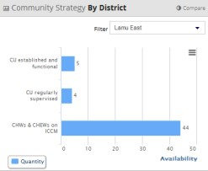

This represents the community strategy aggregated analysis of the facilities in a specific district in the selected county.

After selecting the county above, you need to select a specific region within the county.

In this case, only medical facilities located in Lamu East District in Lamu county.

For instance, in the above analysis;

* CU is established and functional in 5 Lamu East facilities surveyed so far
* CU is regularly supervised in 4 Lamu East facilities surveyed so far
* CHWs & CHEWs on ICCM in 44 Lamu East facilities surveyed so far
* CU is supported by incentives for CHW in 0 Lamu East facilities surveyed so far
* Cases treated with Zinc & ORS are 0 in Lamu East facilities surveyed so far



**Facility Strategy**

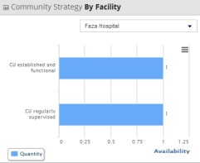

This represents the community strategy analysis of a specific facility in a particular district in the selected county.

After selecting the district/region above, you need to select a specific facility within that region.

In this case, Feza Hospital in Lamu East District in Lamu county

For instance, in the above analysis;

* CU is established and functional in Feza Hospital in Lamu East
* CU is regularly supervised in Feza Hospital in Lamu East
* CHWs & CHEWs on ICCM is absent in Feza Hospital in Lamu East
* CU is supported by incentives for CHW is absent in Feza Hospital in Lamu East • Cases treated with Zinc & ORS are absent in Feza Hospital in Lamu East

### Staff Training

## Signal Functions

This section shall focus on the 'signals' sub-menu of the 'analytics' menu.

We shall review the various factors falling under 'signal functions' in detail. They are as follows:

Commodities Analytics

* CEmONC Signal Function
* BEmONC Signal Function
* BEmONC Signal Function Challenges

### CEmONC Signal Function

### BEmONC Signal Function

### BEmONC Signal Function Challenges

## Commodities

This section shall focus on the 'commodities' sub-menu of the 'analytics' menu.

We shall review the various factors falling under 'commodities' in detail. They are as follows:

Commodities Analytics

* Commodity Availability
* Commodity Reasons For Unavailability
* Commodity Location
* Commodity Quantities
* Commodity Suppliers

### Commodity Availability

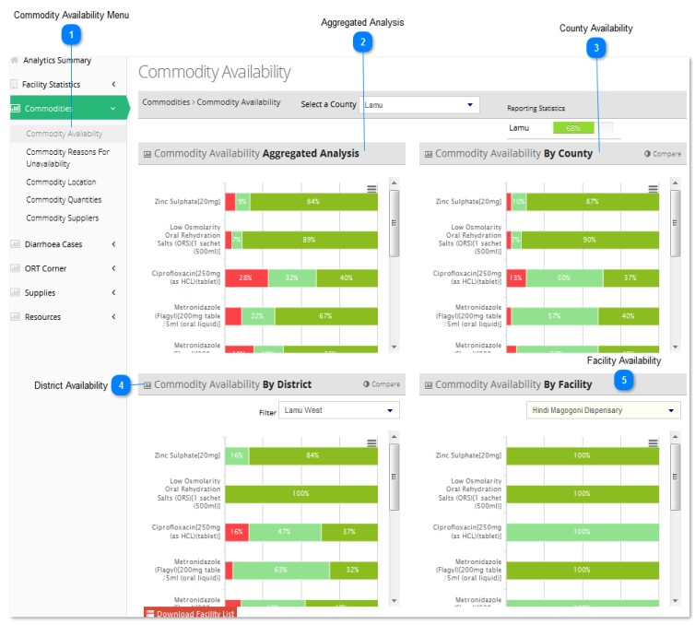

The figure above illustrates the 'commodity availability' analytics for Lamu County



**Commodity Availability Menu**

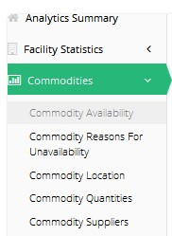

'Commodity availability' is a sub-menu of the 'Facility Statistics' menu.

To access items under the 'Facility Statistics' menu, click on 'commodity availability' and the submenu shall be revealed.

In this case, 'commodity availability' of Lamu County has been selected and the various charts have been displayed.



**Aggregated Analysis**

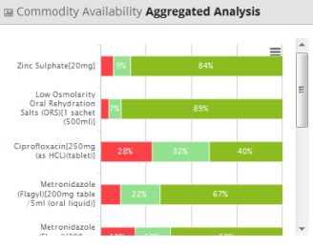

This is an aggregated analysis of the guidelines availability across the entire region (all counties included).

For instance, in the above analysis, the availability of various drugs is outlined as a percentage of all the counties in the region.



**County Availability**

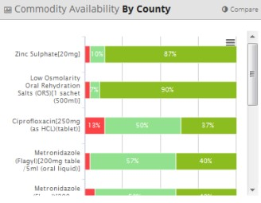

This represents the services offered aggregated analysis of all the facilities in a specific county. In this case, all facilities located in Lamu county.

For instance, in the above analysis, the availability of various drugs is outlined as a percentage of all the facilities in the specified county.



**District Availability**

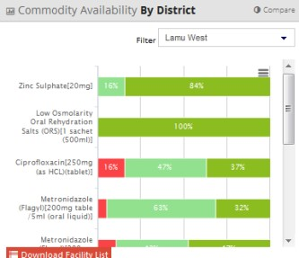

This represents the services offered aggregated analysis of the facilities in a specific district in the selected county. After selecting the county above, you need to select a specific region within the county.

In this case, only medical facilities located in Lamu West District in Lamu county.

For instance, in the above analysis, the availability of various drugs is outlined as a percentage of all the facilities in Lamu West.



**Facility Availability**

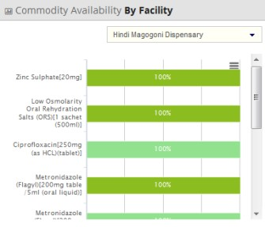

This represents the services offered analysis of a specific facility in a particular district in the selected county.

After selecting the district/region above, you need to select a specific facility within that region.

In this case, Hindi Magogoni Dispensary in Lamu West District in Lamu county

For instance, in the above analysis, the availability of various drugs in Hindi Magogoni Dispensary is outlined as a percentage. 100% means the drug is available while 0% means the drug is absent.

### Commodity Unavailability

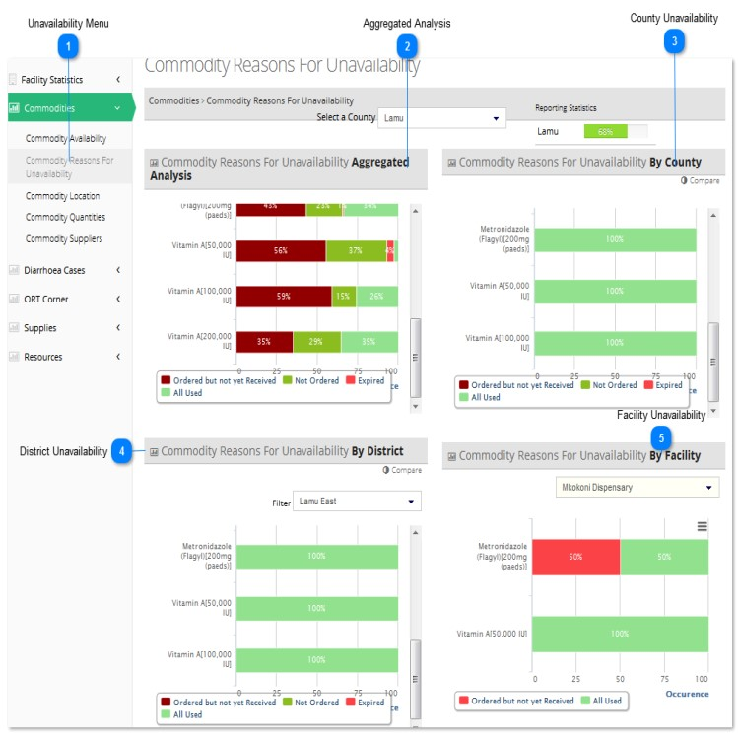

The figure above illustrates the 'reasons for commodity unavailability' analytics for Lamu County



**Unavailability Menu**

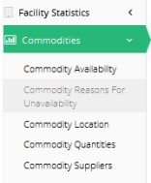

'Commodity unavailability' is a sub-menu of the 'Facility Statistics' menu.

To access items under the 'Facility Statistics' menu, click on 'commodity unavailability' and the submenu shall be revealed.

In this case, 'commodity unavailability of Lamu County has been selected and the various charts have been displayed.



**Aggregated Analysis**

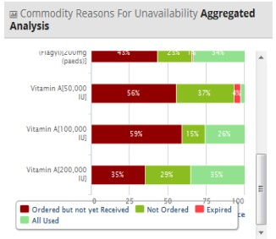

This is an aggregated analysis of the 'reasons for commodity unavailability' across the entire region (all counties included).

For instance, in the above analysis, using the key provided the reasons for unavailability of various drugs is outlined as a percentage of all the counties in the region.



**County Unavailability**

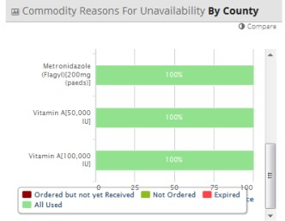

This represents the 'reasons for commodity unavailability’ aggregated analysis of all the facilities in a specific county.

In this case, all facilities located in Lamu county.

For instance, in the above analysis, using the key provided the reasons for unavailability of various drugs is outlined as a percentage of all the facilities in the specified county.



**District Unavailability**

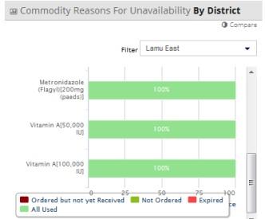

This represents the 'reasons for commodity unavailability' aggregated analysis of the facilities in a specific district in the selected county.

After selecting the county above, you need to select a specific region within the county.

In this case, only medical facilities located in Lamu East District in Lamu county.

For instance, in the above analysis, using the key provided, the unavailability of various drugs is outlined as a percentage of all the facilities in Lamu East.



**Facility Unavailability**

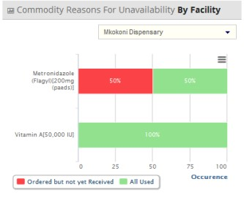

This represents the 'reasons for commodity unavailability' analysis of a specific facility in a particular district in the selected county.

After selecting the district/region above, you need to select a specific facility within that region.

In this case, Mkokoni Dispensary in Lamu East District in Lamu county

For instance, in the above analysis, the availability of various drugs in Mkokoni Dispensary is outlined as a percentage.

For the drug called Metronidazole, the 50%/50% bar indicates that the drug has been completely used up but an order for more has also been placed while for Vitamin A, the drug has been completely used up but more is yet to be received.

### Commodity Location

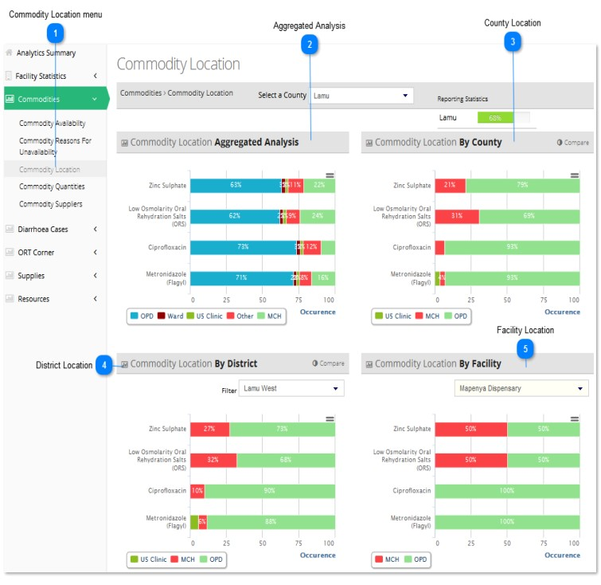

The figure above illustrates the 'commodity location' analytics for Lamu County



**Commodity Location menu**

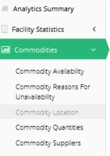

'Commodity location' is a sub-menu of the 'Facility Statistics' menu.

To access items under the 'Facility Statistics' menu, click on 'commodity location' and the submenu shall be revealed.

In this case, 'commodity location' of Lamu County has been selected and the various charts have been displayed.



**Aggregated Analysis**

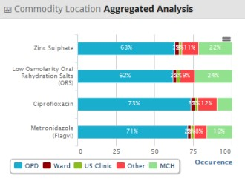

This is an aggregated analysis of the 'commodity location' across the entire region (all counties included).

For instance, in the above analysis, using the key provided, the commodity location is outlined as a percentage of all the surveyed counties in the region.



**County Location**

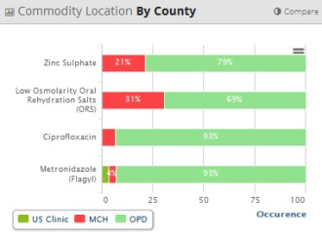

This represents the 'commodity location’ aggregated analysis of all the facilities in a specific county. In this case, all facilities located in Lamu county.

For instance, in the above analysis, using the key provided, the commodity location is outlined as a percentage of all the facilities in the specified county.



**District Location**

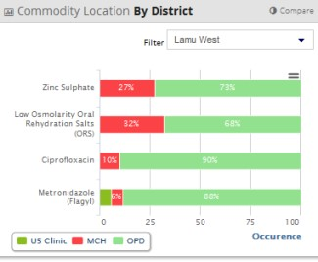

This represents the 'commodity location' aggregated analysis of the facilities in a specific district in the selected county.

After selecting the county above, you need to select a specific region within the county.

In this case, only medical facilities located in Lamu West District in Lamu county.

For instance, in the above analysis, using the key provided, the commodity location is outlined as a percentage of all the facilities in Lamu West.



**Facility Location**

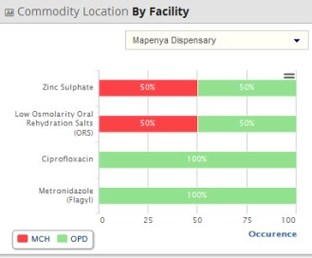

This represents the 'commodity location' analysis of a specific facility in a particular district in the selected county.

After selecting the district/region above, you need to select a specific facility within that region.

In this case, Mapenya Dispensary in Lamu West District in Lamu county

For instance, in the above analysis, using the key provided, the 'commodity location' of various drugs in Mapenya Dispensary is outlined as a percentage.

### Commodity Quantities

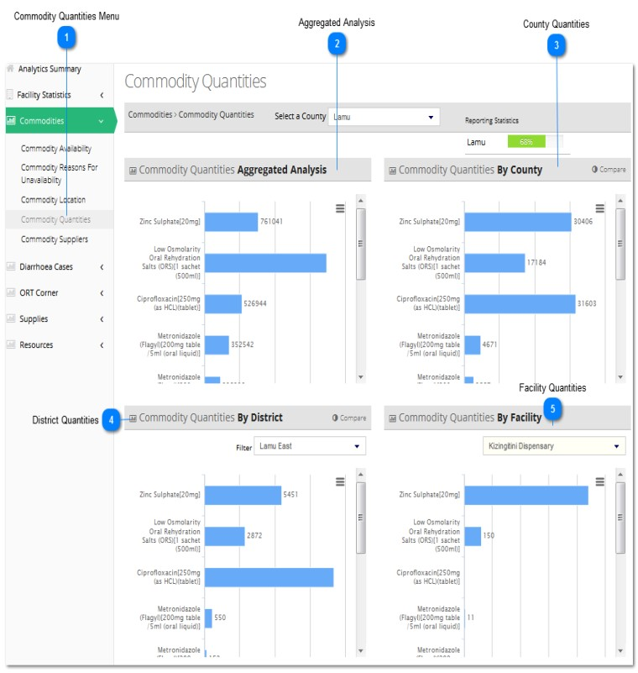

The figure above illustrates the 'commodity quantities' analytics for Lamu County



**Commodity Quantities Menu**

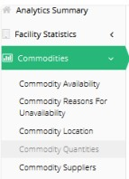

'Commodity quantity' is a sub-menu of the 'Facility Statistics' menu.

To access items under the 'Facility Statistics' menu, click on 'commodity quantity' and the submenu shall be revealed.

In this case, 'commodity quantity' of Lamu County has been selected and the various charts have been displayed.



**Aggregated Analysis**

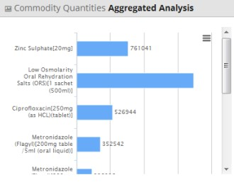

This is an aggregated analysis of the 'commodity quantities' across the entire region (all counties included).

For instance, in the above analysis, the commodity quantity is outlined as a total of all the surveyed counties in the region.



**County Quantities**

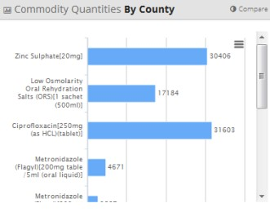

This represents the 'commodity quantities’ aggregated analysis of all the facilities in a specific county. In this case, all facilities located in Lamu county.

For instance, in the above analysis, the commodity quantity is outlined as a total of all the facilities in the specified county.



**District Quantities**

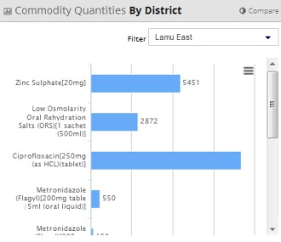

This represents the 'commodity quantity' aggregated analysis of the facilities in a specific district in the selected county.

After selecting the county above, you need to select a specific region within the county.

In this case, only medical facilities located in Lamu East District in Lamu county.

For instance, in the above analysis, the commodity quantity is outlined as a total of all the facilities in Lamu East.



**Facility Quantities**

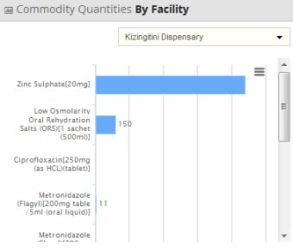

This represents the 'commodity location' analysis of a specific facility in a particular district in the selected county.

After selecting the district/region above, you need to select a specific facility within that region.

In this case, Kizingitini Dispensary in Lamu East District in Lamu county

For instance, in the above analysis, the 'commodity quantity' of various drugs in Kizingitini Dispensary is outlined as a total.

### Commodity Suppliers

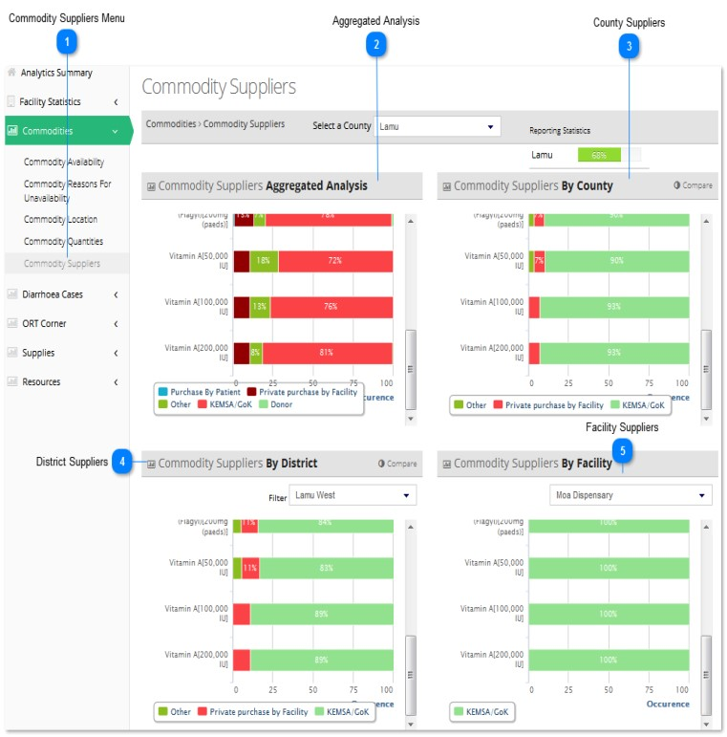

The figure above illustrates the 'commodity suppliers' analytics for Lamu County



**Commodity Suppliers Menu**

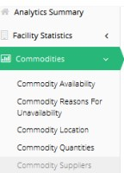

'Commodity suppliers' is a sub-menu of the 'Facility Statistics' menu.

To access items under the 'Facility Statistics' menu, click on 'commodity suppliers' and the submenu shall be revealed.

In this case, 'commodity suppliers' of Lamu County has been selected and the various charts have been displayed.



**Aggregated Analysis**

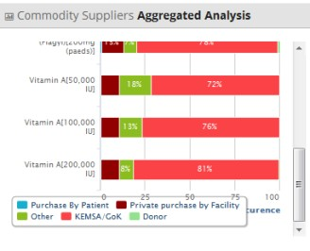

This is an aggregated analysis of the 'commodity suppliers' across the entire region (all counties included).

For instance, in the above analysis, using the key provided, the commodity supplier is outlined as a percentage of all the surveyed counties in the region.



**County Suppliers**

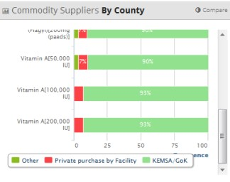

This represents the 'commodity suppliers’ aggregated analysis of all the facilities in a specific county. In this case, all facilities located in Lamu county.

For instance, in the above analysis, using the key provided, the commodity supplier is outlined as a percentage of all the facilities in the specified county.



**District Suppliers**

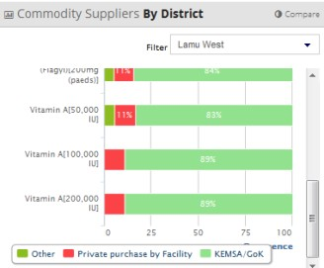

This represents the 'commodity suppliers' aggregated analysis of the facilities in a specific district in the selected county.

After selecting the county above, you need to select a specific region within the county.

In this case, only medical facilities located in Lamu West District in Lamu county.

For instance, in the above analysis, using the key provided, the commodity supplier is outlined as a percentage of all the facilities in Lamu West.



**Facility Suppliers**

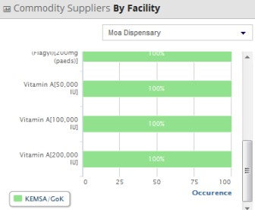

This represents the 'commodity suppliers' analysis of a specific facility in a particular district in the selected county.

After selecting the district/region above, you need to select a specific facility within that region.

In this case, Moa Dispensary in Lamu West District in Lamu county

For instance, in the above analysis, using the key provided, the 'commodity supplier' of various drugs in Moa Dispensary is outlined as a percentage.

## EQUIPMENT

This section shall focus on the 'Equipment' sub-menu of the 'Analytics' menu.

We shall review the various factors falling under 'Equipment' in detail. They are as follows:

Equipment Analytics

* Equipment Availability
* Equipment Location
* Equipment Functionality

### Equipment Availability

### Equipment Location

### Equipment Functionality

## Supplies

This section shall focus on the 'Supplies' sub-menu of the 'Analytics' menu.

We shall review the various factors falling under 'Supplies' in detail. They are as follows:

Supplies Analytics

* Supplies Availability
* Supplies Location
* Suppliers

### Supplies Availability

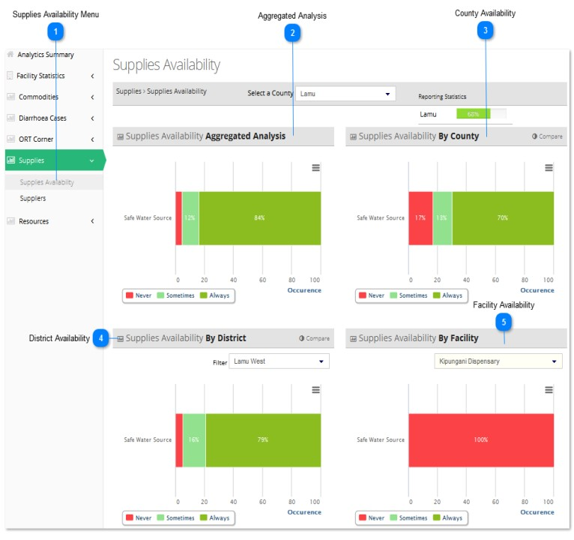

The figure above illustrates the 'supplies availability' analytics for Lamu County



**Supplies Availability Menu**

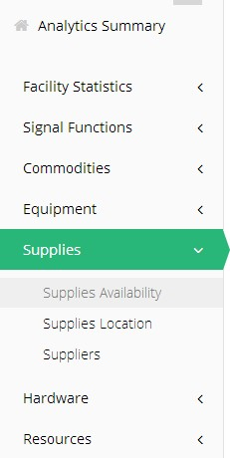

'Supplies availability' is a sub-menu of the 'Facility Statistics' menu.

To access items under the 'Facility Statistics' menu, click on 'supplies availability' and the submenu shall be revealed.

In this case, 'supplies availability' of Lamu County has been selected and the various charts have been displayed.



**Aggregated Analysis**

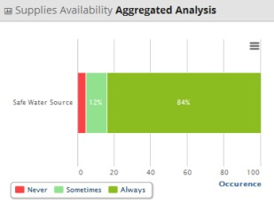

This is an aggregated analysis of the 'supplies availability' across the entire region (all counties included).



**County Availability**

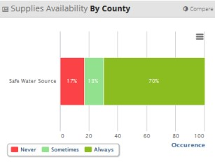

This represents the 'supplies availability' aggregated analysis of all the facilities in a specific county. In this case, all facilities located in Lamu county.



**District Availability**

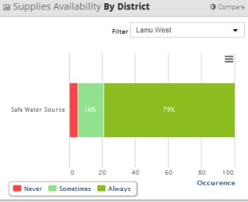

This represents the 'supplies availability' aggregated analysis of the facilities in a specific district in the selected county.

In this case, only medical facilities located in Lamu West District in Lamu county.



**Facility Availability**

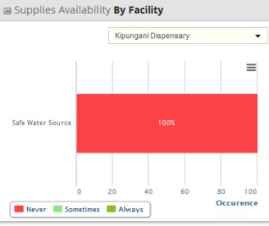

This represents the 'supplies availability' analysis of a specific facility in a particular district in the selected county.

In this case, Kipungani Dispensary in Lamu West District in Lamu county

### Supplies Location

### Suppliers

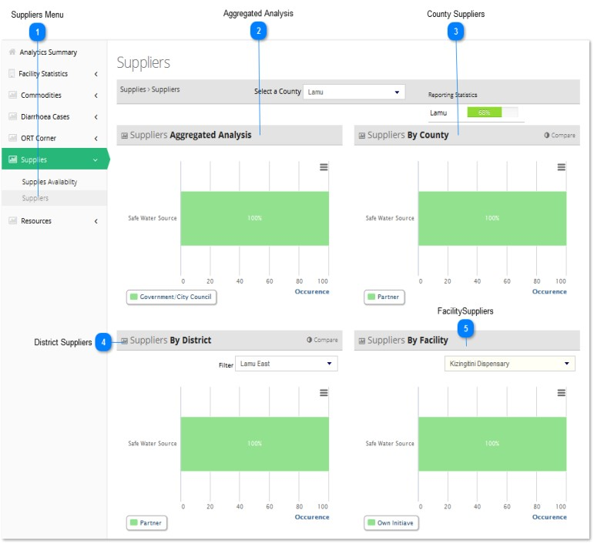

The figure above illustrates the 'suppliers' analytics for Lamu County



**Suppliers Menu**

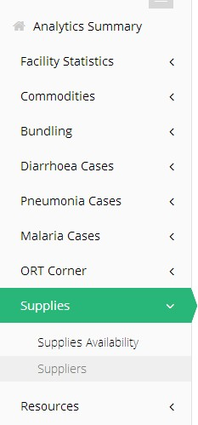

'Suppliers' is a sub-menu of the 'Facility Statistics' menu.

To access items under the 'Facility Statistics' menu, click on 'suppliers' and the submenu shall be revealed.

In this case, 'suppliers' of Lamu County has been selected and the various charts have been displayed.



**Aggregated Analysis**

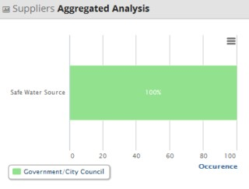

This is an aggregated analysis of the 'suppliers' across the entire region (all counties included).



**County Suppliers**

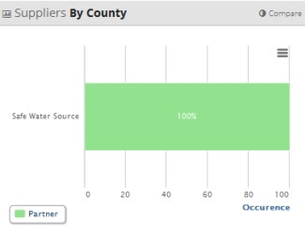

This represents the 'suppliers' aggregated analysis of all the facilities in a specific county.

In this case, all facilities located in Lamu county.



**District Suppliers**

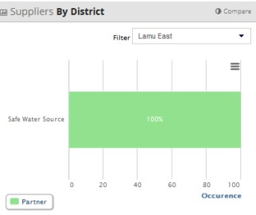

This represents the 'suppliers' aggregated analysis of the facilities in a specific district in the selected county. In this case, only medical facilities located in Lamu East District in Lamu county.



**Facility Suppliers**

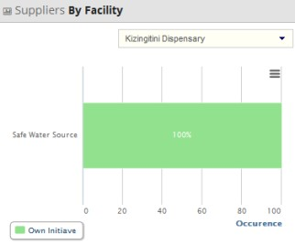

This represents the 'suppliers' analysis of a specific facility in a particular district in the selected county.

In this case, Kizingitini Dispensary in Lamu East District in Lamu county

## Hardware

This section shall focus on the 'Resources' sub-menu of the 'Resources' menu.

We shall review the various factors falling under 'Resources' in detail. They are as follows:

Resource Analytics

* Hardware Availability

### Hardware Availability

## Resources

This section shall focus on the 'Resources' sub-menu of the 'Resources' menu.

We shall review the various factors falling under 'Resources' in detail. They are as follows:

Resource Analytics

* Resource Availability
* Resource Location

### Resource Availability

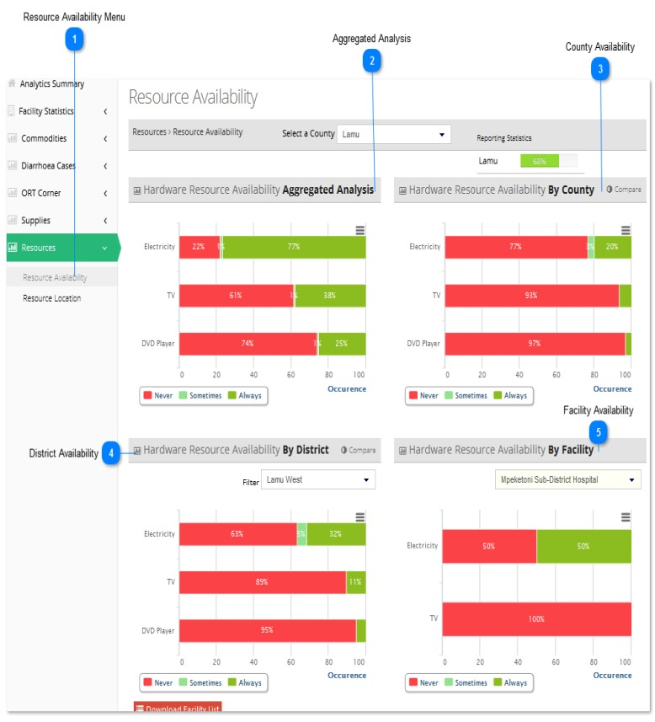

The figure above illustrates the 'resource availability' analytics for Lamu County



**Resource Availability Menu**

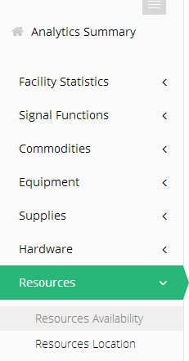

'Resource availability' is a sub-menu of the 'Facility Statistics' menu.

To access items under the 'Facility Statistics' menu, click on 'resource availability' and the submenu shall be revealed.

In this case, 'resource availability' of Lamu County has been selected and the various charts have been displayed.



**Aggregated Analysis**

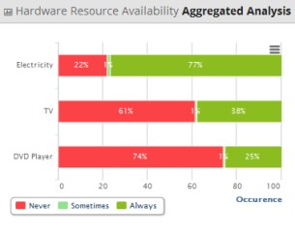

This is an aggregated analysis of the 'resource availability' across the entire region (all counties included).



**County Availability**

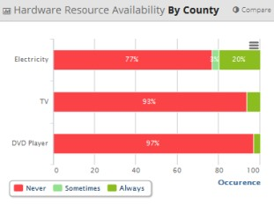

This represents the 'resource availability' aggregated analysis of all the facilities in a specific county. In this case, all facilities located in Lamu county.



**District Availability**

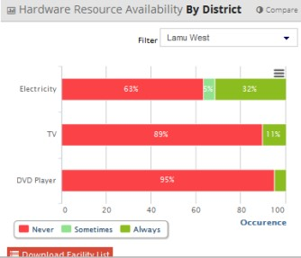

This represents the 'resource availability' aggregated analysis of the facilities in a specific district in the selected county.

In this case, only medical facilities located in Lamu West District in Lamu county.



**Facility Availability**

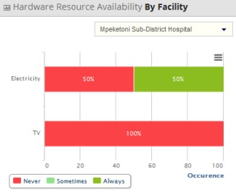

This represents the 'resource availability' analysis of a specific facility in a particular district in the selected county.

In this case, Mpehetoni Sub-District Hospital in Lamu West District in Lamu county

### Resource Location

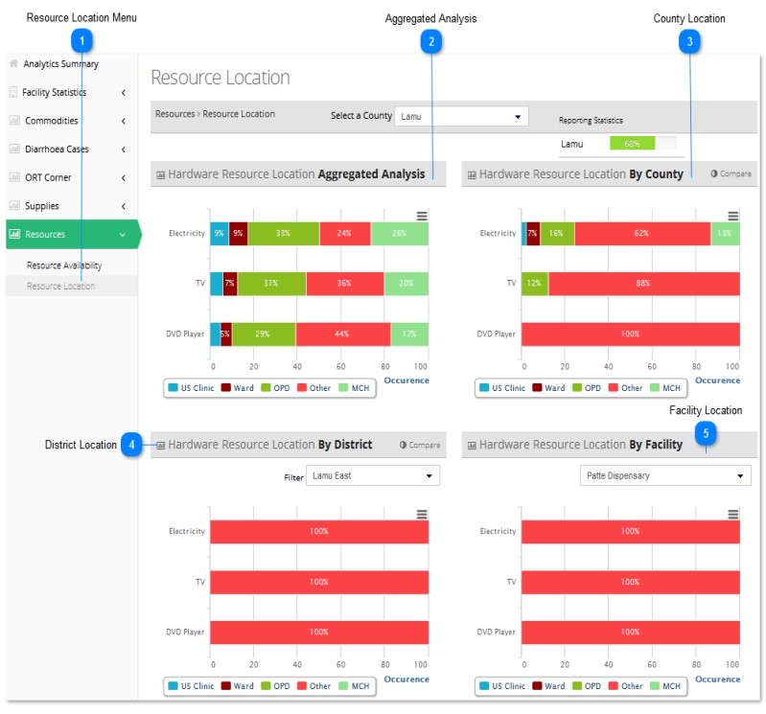

The figure above illustrates the 'resource location' analytics for Lamu County



**Resource Location Menu**

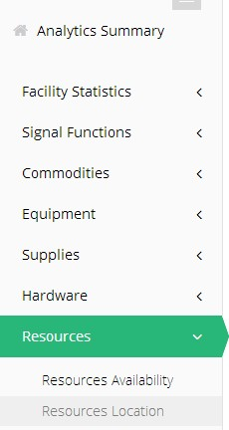

'Resource location'' is a sub-menu of the 'Facility Statistics' menu.

To access items under the 'Facility Statistics' menu, click on 'resource location' and the submenu shall be revealed.

In this case, 'resource location' of Lamu County has been selected and the various charts have been displayed.



**Aggregated Analysis**

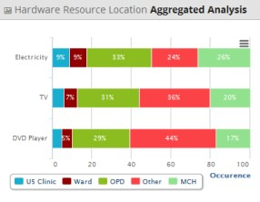

This is an aggregated analysis of the 'resource location' across the entire region (all counties included).



**County Location**

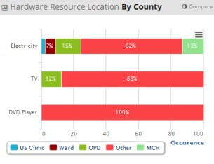

This represents the 'resource location' aggregated analysis of all the facilities in a specific county.

In this case, all facilities located in Lamu county.



**District Location**

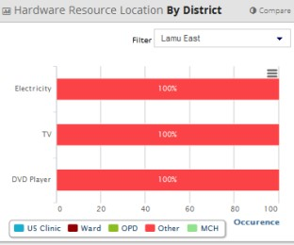

This represents the 'resource location' aggregated analysis of the facilities in a specific district in the selected county.

In this case, only medical facilities located in Lamu East District in Lamu county.



**Facility Location**

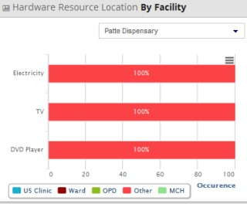

This represents the 'resource location' analysis of a specific facility in a particular district in the selected county.

In this case, Patte Dispensary in Lamu East District in Lamu county

# CH Analytics

This section shall focus on the 'facility analytics' sub-menu of the 'analytics' menu.

We shall review the various factors falling under 'facility analytics' in detail. They are as follows:

Facility Analytics

* Community Strategy
* Guidelines Availability
* Staff Training
* Services Offered
* Danger Signs
* Actions Performed
* Counsel Given
* Tools in a given Unit
* Consultation
* Health Services
* Case Management
* IMCI Consultation Room

## FACILITY STATISTICS

### Community Strategy

### Guidelines Availability

### Staff Training

### Services Offered

### Danger Signs

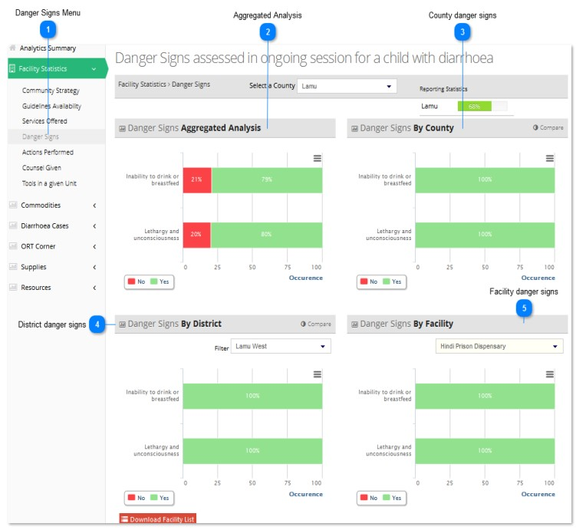

The figure above illustrates the 'danger signs' analytics for Lamu County



**Danger Signs Menu**

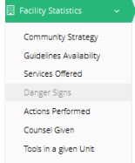

'Danger Signs' is a sub-menu of the 'Facility Statistics' menu.

To access items under the 'Facility Statistics' menu, click on 'Danger Signs' and the submenu shall be revealed.

In this case, 'Danger Signs' of Lamu County has been selected and the various charts have been displayed.



**Aggregated Analysis**

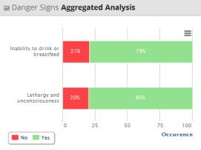

This is an aggregated analysis of the danger signs in facilities across the entire region (all counties included).

For instance, in the above analysis;

* Inability to drink or breastfeed is present in 79% of the total facilities surveyed so far in the entire region
* Lethargy and unconsciousness is present in 80% of the total facilities surveyed so far in the entire region



**County danger signs**

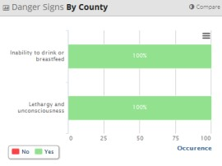

This represents the services offered aggregated analysis of all the facilities in a specific county. In this case, all facilities located in Lamu county.

For instance, in the above analysis;

* Inability to drink or breastfeed is present in 100% of the total facilities surveyed so far in the entire county
* Lethargy and unconsciousness is present in 100% of the total facilities surveyed so far in the entire county



**District danger signs**

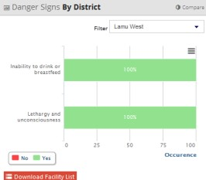

This represents the services offered aggregated analysis of the facilities in a specific district in the selected county.

After selecting the county above, you need to select a specific region within the county.

In this case, only medical facilities located in Lamu West District in Lamu county.

For instance, in the above analysis;

* Inability to drink or breastfeed is present in 100% of the total facilities surveyed so far in Lamu West
* Lethargy and unconsciousness is present in 100% of the total facilities surveyed so far in Lamu West



**Facility danger signs**

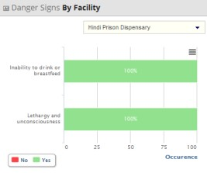

This represents the services offered analysis of a specific facility in a particular district in the selected county.

After selecting the district/region above, you need to select a specific facility within that region.

In this case, Hindi Prison Dispensary in Lamu West District in Lamu county

For instance, in the above analysis;

* Inability to drink or breastfeed is present in Hindi Prison Dispensary in Lamu West
* Inability to drink or breastfeed is present in Hindi Prison Dispensary in Lamu West

### Actions Performed

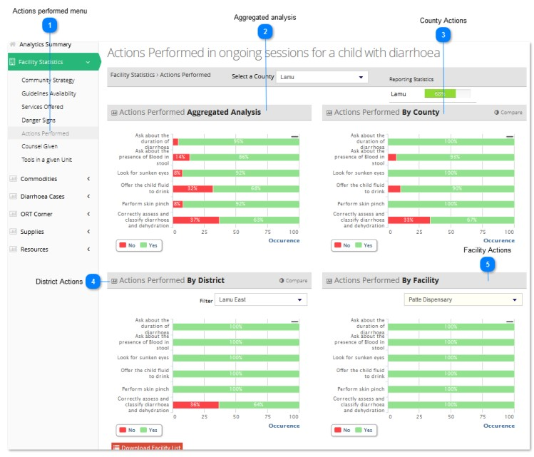

The figure above represents the 'actions performed' analytics for Lamu County



**Actions performed menu**

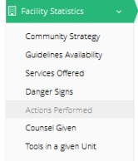

'Actions Performed' is a sub-menu of the 'Facility Statistics' menu.

To access items under the 'Facility Statistics' menu, click on 'Actions Performed' and the submenu shall be revealed.

In this case, 'Actions Performed' of Lamu County has been selected and the various charts have been displayed.



**Aggregated analysis**

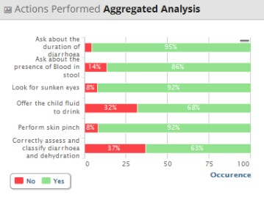

This is an aggregated analysis of the services offered in facilities across the entire region (all counties included).

For instance, in the above analysis;

* Duration of diarrhoea inquiry is practiced in 95% of the total facilities surveyed so far in the entire region
* Presence of blood in stool inquiry is practiced in 86% of the total facilities surveyed so far in the entire region
* Investigation of sunken eyes is practiced in 92% of the total facilities surveyed so far in the entire region
* Offering fluid to drink is practiced in 68% of the total facilities surveyed so far in the entire region
* Performing skin pinch is practiced in 92% of the total facilities surveyed so far in the entire region
* Correctly assessing and classifying diarrhoea and dehydration is successful in 63% of the total facilities surveyed so far in the entire region



**County Actions**

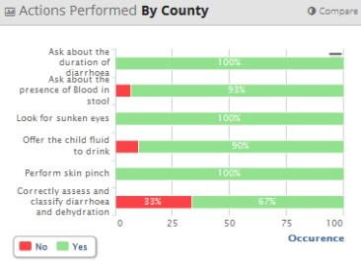

This represents the services offered aggregated analysis of all the facilities in a specific county. In this case, all facilities located in Lamu county.

For instance, in the above analysis;

* Duration of diarrhoea inquiry is practiced in 100% of the total facilities surveyed so far in the entire county
* Presence of blood in stool inquiry is practiced in 93% of the total facilities surveyed so far in the entire county
* Investigation of sunken eyes is practiced in 100% of the total facilities surveyed so far in the entire county
* Offering fluid to drink is practiced in 90% of the total facilities surveyed so far in the entire county
* Performing skin pinch is practiced in 100% of the total facilities surveyed so far in the entire county
* Correctly assessing and classifying diarrhoea and dehydration is successful in 67% of the total facilities surveyed so far in the entire county



**District Actions**

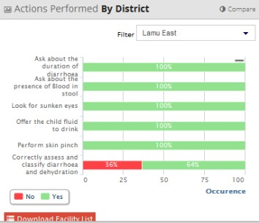

This represents the services offered aggregated analysis of the facilities in a specific district in the selected county.

After selecting the county above, you need to select a specific region within the county.

In this case, only medical facilities located in Lamu East District in Lamu county.

For instance, in the above analysis;

* Duration of diarrhoea inquiry is practiced in 100% of the total facilities surveyed so far in Lamu East
* Presence of blood in stool inquiry is practiced in 100% of the total facilities surveyed so far in Lamu East
* Investigation of sunken eyes is practiced in 100% of the total facilities surveyed so far in Lamu East
* Offering fluid to drink is practiced in 100% of the total facilities surveyed so far in Lamu East
* Performing skin pinch is practiced in 100% of the total facilities surveyed so far in Lamu East
* Correctly assessing and classifying diarrhoea and dehydration is successful in 64% of the total facilities surveyed so far in Lamu East



**Facility Actions**

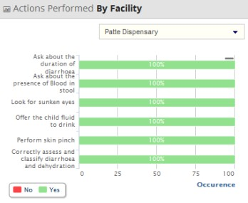

This represents the services offered analysis of a specific facility in a particular district in the selected county.

After selecting the district/region above, you need to select a specific facility within that region.

In this case, Patte Dispensary in Lamu East District in Lamu county

For instance, in the above analysis;

* Duration of diarrhoea inquiry is practiced in Patte Dispensary in Lamu East
* Presence of blood in stool inquiry is practiced in Patte Dispensary in Lamu East
* Investigation of sunken eyes is practiced in Patte Dispensary in Lamu East
* Offering fluid to drink is practiced in Patte Dispensary in Lamu East
* Performing skin pinch is practiced in Patte Dispensary in Lamu East
* Correctly assessing and classifying diarrhoea and dehydration is successful in Patte Dispensary in Lamu East

### Counsel Given

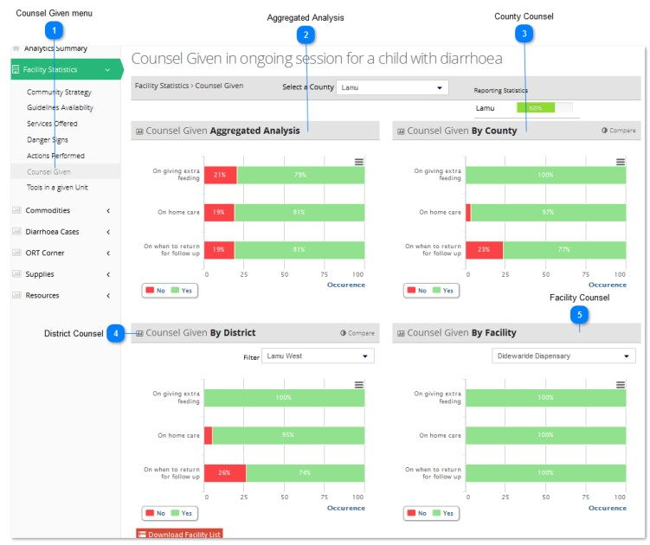

The figure above represents the 'counsel given' analytics for Lamu County



**Counsel Given menu**

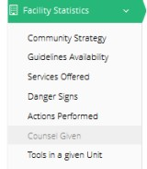

'Counsel given' is a sub-menu of the 'Facility Statistics' menu.

To access items under the 'Facility Statistics' menu, click on 'Counsel Given' and the submenu shall be revealed.

In this case, 'Counsel Given' of Lamu County has been selected and the various charts have been displayed.



**Aggregated Analysis**

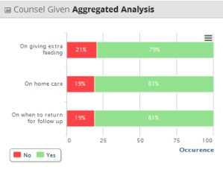

This is an aggregated analysis of the guidelines availability across the entire region (all counties included).

For instance, in the above analysis;

* Counsel given on giving extra feeding is present in 79% of the total facilities surveyed so far in the entire region
* Counsel given on home care is present in 81% of the total facilities surveyed so far in the entire region
* Counsel given on when to return for follow up visits is present in 81% of the total facilities surveyed so far in the entire region



**County Counsel**

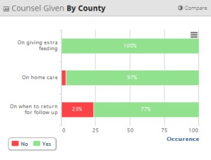

This represents the services offered aggregated analysis of all the facilities in a specific county. In this case, all facilities located in Lamu county.

For instance, in the above analysis;

* Counsel given on giving extra feeding is present in 100% of the total facilities surveyed so far in the entire county
* Counsel given on home care is present in 97% of the total facilities surveyed so far in the entire county
* Counsel given on when to return for follow up visits is present in 77% of the total facilities surveyed so far in the entire county



**District Counsel**

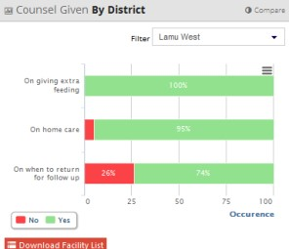

This represents the services offered aggregated analysis of the facilities in a specific district in the selected county. After selecting the county above, you need to select a specific region within the county.

For instance, in the above analysis;

* Counsel given on giving extra feeding is present in 100% of the total facilities surveyed so far in Lamu West district
* Counsel given on home care is present in 95% of the total facilities surveyed so far in Lamu West district
* Counsel given on when to return for follow up visits is present in 74% of the total facilities surveyed so far in Lamu West district



**Facility Counsel**

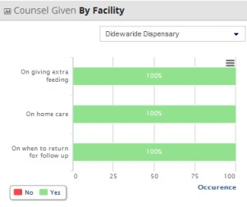

This represents the services offered analysis of a specific facility in a particular district in the selected county.

After selecting the district/region above, you need to select a specific facility within that region.

In this case, Feza Hospital in Lamu East District in Lamu county

For instance, in the above analysis;

* Counsel given on giving extra feeding is practiced in practiced in Didewaride Dispensary in Lamu West
* Counsel given on home care is practiced in in Didewaride Dispensary in Lamu West
* Counsel given on when to return for follow up visits is practiced in in Didewaride Dispensary in Lamu West

### Tools in a Given Unit

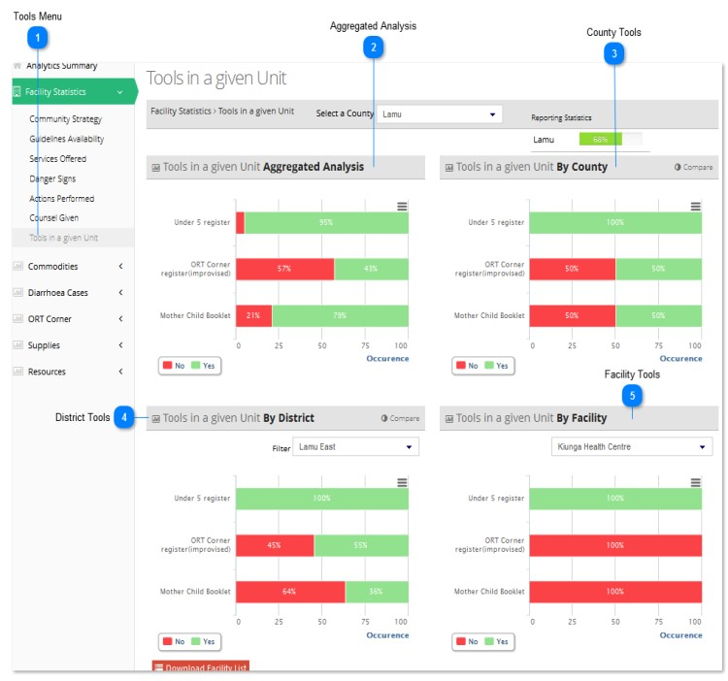

The figure above represents the 'tools' analytics for Lamu County



**Tools Menu**

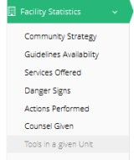

'Tools' is a sub-menu of the 'Facility Statistics' menu.

To access items under the 'Facility Statistics' menu, click on 'tools' and the submenu shall be revealed.

In this case, 'tools' of Lamu County has been selected and the various charts have been displayed.



**Aggregated Analysis**

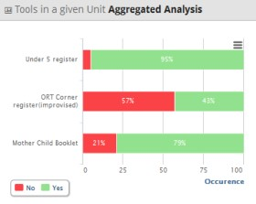

This is an aggregated analysis of the guidelines availability across the entire region (all counties included).

For instance, in the above analysis;

* The under 5 register is present in 95% of the total facilities surveyed so far in the entire region
* The ORT Corner register is present in 43% of the total facilities surveyed so far in the entire region
* The Mother Child Booklet is present in 79% of the total facilities surveyed so far in the entire region



**County Tools**

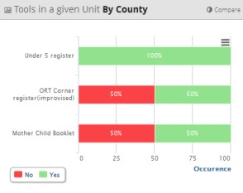

This represents the services offered aggregated analysis of all the facilities in a specific county. In this case, all facilities located in Lamu county.

For instance, in the above analysis;

* The under 5 register is present in 100% of the total facilities surveyed so far in the entire county
* The ORT Corner register is present in 50% of the total facilities surveyed so far in the entire county
* The Mother Child Booklet is present in 50% of the total facilities surveyed so far in the entire county



**District Tools**

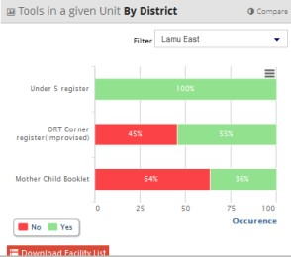

This represents the services offered aggregated analysis of the facilities in a specific district in the selected county. After selecting the county above, you need to select a specific region within the county.

For instance, in the above analysis;

* The under 5 register is present in 100% of the total facilities surveyed so far in Lamu East district
* The ORT Corner register is present in 55% of the total facilities surveyed so far in Lamu East district
* The Mother Child Booklet is present in 36% of the total facilities surveyed so far in Lamu East district



**Facility Tools**

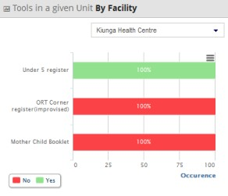

This represents the services offered analysis of a specific facility in a particular district in the selected county.

After selecting the district/region above, you need to select a specific facility within that region.

In this case, Kiunga Health Centre in Lamu East District in Lamu County

For instance, in the above analysis;

* The under 5 register is present in Kiunga Health Centre in Lamu East
* The ORT Corner register is absent in Kiunga Health Centre in Lamu East

The Mother Child Booklet is absent

### Consultation

### Health Services

### Case Management

### IMCI Consultation Room

## COMMODITIES

This section shall focus on the 'commodities' sub-menu of the 'analytics' menu.

We shall review the various factors falling under 'Commodities' in detail. They are as follows:

Commodities Analytics

* Commodity Availability
* Commodity Reasons For Unavailability
* Commodity Location
* Commodity Quantities
* Commodity Suppliers

### Commodity Availability

### Commodity Reasons for Unavailability

### Commodity Location

### Commodity Quantities

### Commodity Suppliers

## BUNDLING

This section shall focus on the 'bundling' sub-menu of the 'analytics' menu.

We shall review the various factors falling under 'Bundling' in detail. They are as follows:

Bundling Analytics

* Commodity Bundling Availability
* Commodity Reasons For Bundling Unavailability
* Bundling Location
* Bundling Quantities
* Bundling Suppliers

### Commodity Bundling Availability

### Commodity Reasons for Bundling Unavailability

### Bundling Location

### Bundling Quantities

### Bundling Suppliers

## Diarrhoea Cases

This section shall focus on the 'diarrhoea cases' sub-menu of the 'analytics' menu.

We shall review the various factors falling under 'diarrhoea cases' in detail. They are as follows:

Diarrhoea Case Analytics

* Case Numbers
* Case Treatment

### Case Numbers

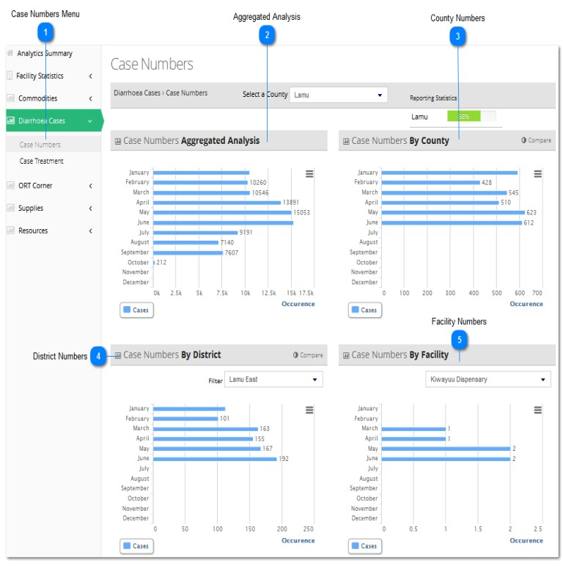

The figure above illustrates the 'diarrhoea case numbers' analytics for Lamu County



**Case Numbers Menu**

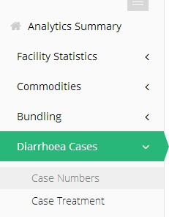

'Case numbers' is a sub-menu of the 'Facility Statistics' menu. It indicates the total number of reported diarrhoea cases in the whole region, per county, per district and per facility surveyed.

To access items under the 'Facility Statistics' menu, click on 'case numbers' and the submenu shall be revealed.

In this case, 'diarrhoea case numbers' of Lamu county has been selected and the various charts have been displayed.



**Aggregated Analysis**

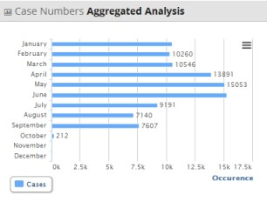

This is an aggregated analysis of the 'diarrhoea case numbers' across the entire region (all counties included) on a monthly basis.

For instance, in the above analysis, the diarrhoea case numbers are outlined in monthly totals of all the cases in the surveyed counties in the region.



**County Numbers**

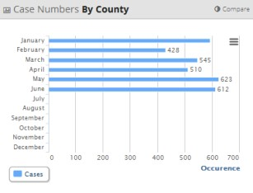

This represents the 'diarrhoea case numbers’ aggregated analysis of all the facilities in a specific county. In this case, all facilities located in Lamu county.

For instance, in the above analysis, the diarrhoea case numbers are outlined in monthly totals of all the cases in the surveyed facilities in the specified county.



**District Numbers**

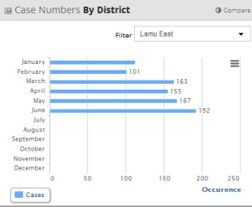

This represents the 'diarrhoea case numbers' aggregated analysis of the facilities in a specific district in the selected county.

After selecting the county above, you need to select a specific region within the county.

In this case, only medical facilities located in Lamu East District in Lamu county.

For instance, in the above analysis, the diarrhoea case numbers are outlined as monthly totals of all the surveyed cases in facilities in Lamu East.



**Facility Numbers**

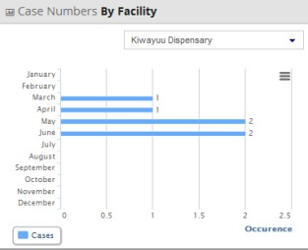

This represents the 'diarrhoea case numbers' analysis of a specific facility in a particular district in the selected county.

After selecting the district/region above, you need to select a specific facility within that region.

In this case, Kiwayuu Dispensary in Lamu East District in Lamu county

For instance, in the above analysis, the 'diarrhoea case numbers' in Kiwayuu Dispensary is outlined as a monthly total.

### Case Treatment

## PNEUMONIA CASES

This section shall focus on the 'Pneumonia cases' sub-menu of the 'analytics' menu.

We shall review the various factors falling under 'Pneumonia cases' in detail. They are as follows:

Pneumonia Case Analytics

* Case Numbers
* Case Treatment

### Case Numbers

### Case Treatment

## MALARIA CASES

This section shall focus on the 'Malaria cases' sub-menu of the 'analytics' menu.

We shall review the various factors falling under 'Malaria cases' in detail. They are as follows:

Malaria Case Analytics

* Case Numbers
* Case Treatment

### Case Numbers

### Case Treatment

## ORT CORNER

This section shall focus on the 'ORT corner' sub-menu of the 'analytics' menu.

ORT stands for Oral Rehydration Therapy.

ORT Corners are places where mothers/parents can easily access lifesaving rehydration for their sick children.

When ORT Corners are established, the number of children ultimately admitted to the hospital with severe dehydration reduces dramatically.

We shall review the various factors falling under 'ORT corner' in detail. They are as follows:

ORT Corner Analytics

* ORT Corner Assessment
* ORT Corner Equipment Availability
* ORT Corner Equipment Functionality
* ORT Corner Equipment Location

### ORT Corner Assessment

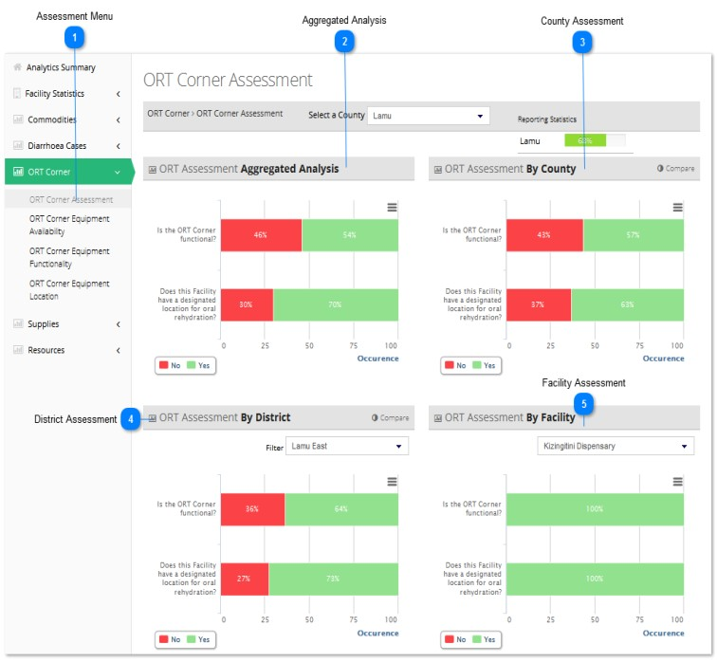

The figure above illustrates the 'ORT corner assessment' analytics for Lamu County



**Assessment Menu**

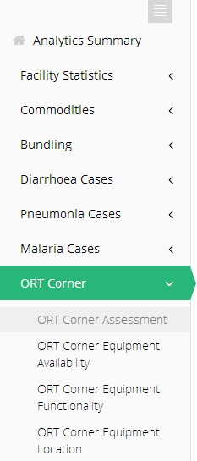

'ORT corner assessment' is a sub-menu of the 'Facility Statistics' menu.

To access items under the 'Facility Statistics' menu, click on 'ORT corner assessment' and the submenu shall be revealed.

In this case, 'ORT corner assessment' of Lamu County has been selected and the various charts have been displayed.



**Aggregated Analysis**

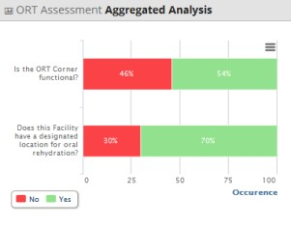

This is an aggregated analysis of the 'ORT corner assessment' across the entire region (all counties included).

This is an aggregated analysis of the danger signs in facilities across the entire region (all counties included).

For instance, in the above analysis;

* ORT Corner functionality is at 54% of the total facilities surveyed so far in the entire region
* Designated oral rehydration location is present in 70% of the total facilities surveyed so far in the entire region



**County Assessment**

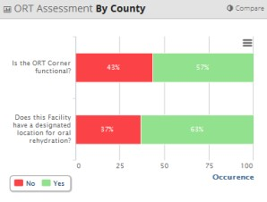

This represents the 'ORT corner assessment' aggregated analysis of all the facilities in a specific county. In this case, all facilities located in Lamu county.

For instance, in the above analysis;

* ORT Corner functionality is at 57% of the total facilities surveyed so far in the entire county
* Designated oral rehydration location is present in 63% of the total facilities surveyed so far in the entire county



**District Assessment**

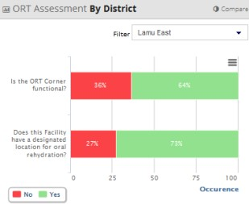

This represents the 'ORT corner assessment' aggregated analysis of the facilities in a specific district in the selected county.

In this case, only medical facilities located in Lamu East District in Lamu county.

For instance, in the above analysis;

* ORT Corner functionality is at 64% of the total facilities surveyed so far in Lamu East district
* Designated oral rehydration location is present in 73% of the total facilities surveyed so far in Lamu East district



**Facility Assessment**

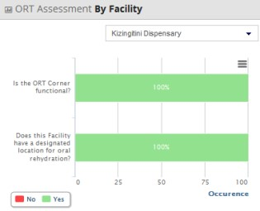

This represents the 'ORT corner assessment' analysis of a specific facility in a particular district in the selected county.

In this case, Kizingitini Dispensary in Lamu East District in Lamu county

For instance, in the above analysis;

* ORT Corner is functional in Kizingitini Dispensary.
* Designated oral rehydration location is present in Kizingitini Dispensary

### ORT Corner Equipment Availability

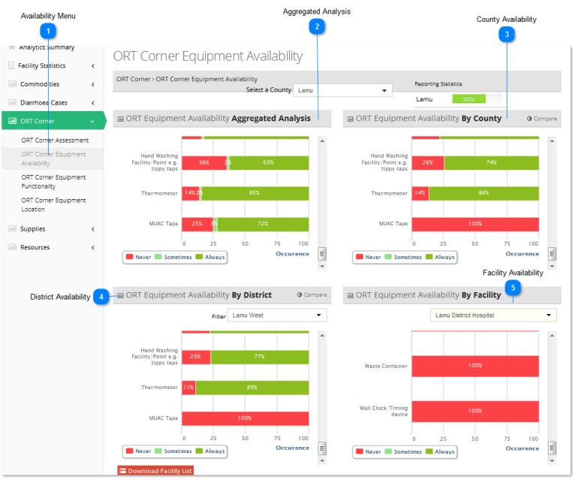

The figure above illustrates the 'ORT corner equipment availability' analytics for Lamu County



**Availability Menu**

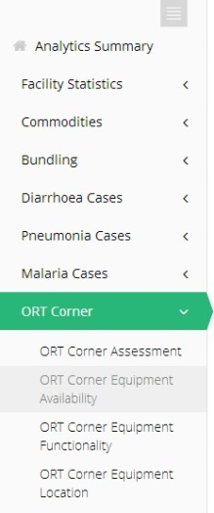

'ORT corner equipment availability' is a sub-menu of the 'Facility Statistics' menu.

To access items under the 'ORT corner equipment availability' menu, click on 'ORT corner equipment availability' and the submenu shall be revealed.

In this case, 'ORT corner equipment availability' of Lamu County has been selected and the various charts have been displayed.



**Aggregated Analysis**

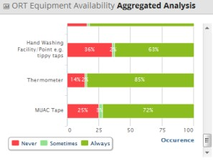

This is an aggregated analysis of the 'ORT corner equipment availability' across the entire region (all counties included).

For instance, in the above analysis, using the key provided, the ORT corner equipment availability is outlined as a percentage of all the surveyed counties in the region.



**County Availability**

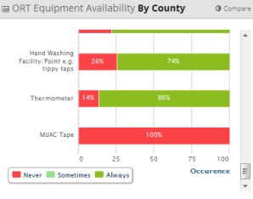

This represents the 'ORT corner equipment availability' aggregated analysis of all the facilities in a specific county.

In this case, all facilities located in Lamu county.

For instance, in the above analysis, using the key provided, the ORT corner equipment availability is outlined as a percentage of all the facilities in the specified county.



**District Availability**

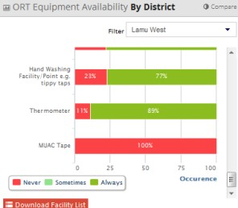

This represents the 'ORT corner equipment availability' aggregated analysis of the facilities in a specific district in the selected county.

After selecting the county above, you need to select a specific region within the county.

In this case, only medical facilities located in Lamu West District in Lamu county.

For instance, in the above analysis, using the key provided, the ORT corner equipment availability is outlined as a percentage of all the facilities in Lamu West.



**Facility Availability**

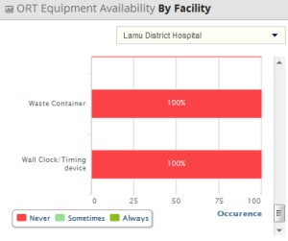

This represents the 'ORT corner equipment availability ‘analysis of a specific facility in a particular district in the selected county.

After selecting the district/region above, you need to select a specific facility within that region.

In this case, Lamu District Hospital in Lamu West District in Lamu county

For instance, in the above analysis, using the key provided, the ORT corner equipment availability in Lamu District Hospital is outlined as a percentage.

### ORT Corner Equipment Functionality

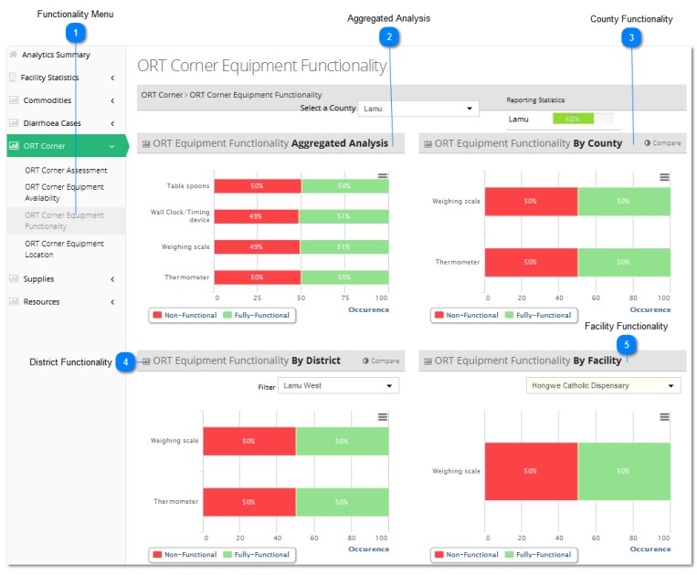

The figure above illustrates the 'ORT corner equipment functionality' analytics for Lamu County



**Functionality Menu**

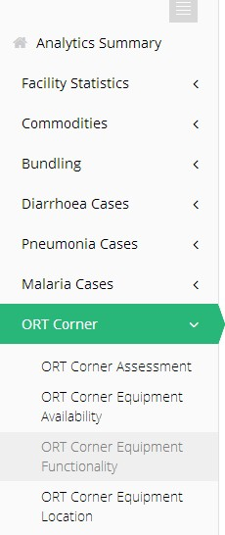

'ORT corner equipment functionality' is a sub-menu of the 'Facility Statistics' menu.

To access items under the 'Facility Statistics' menu, click on 'ORT corner equipment functionality' and the submenu shall be revealed.

In this case, 'ORT corner equipment functionality' of Lamu County has been selected and the various charts have been displayed.



**Aggregated Analysis**

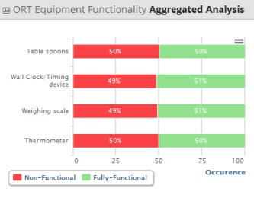

This is an aggregated analysis of the 'ORT corner equipment functionality' across the entire region (all counties included).



**County Functionality**

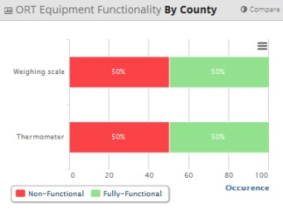

This represents the 'ORT corner equipment functionality’ aggregated analysis of all the facilities in a specific county. In this case, all facilities located in Lamu county.



**District Functionality**

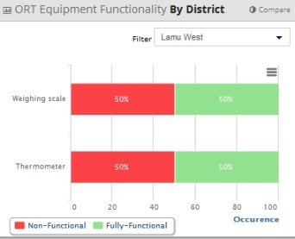

This represents the 'ORT corner equipment functionality' aggregated analysis of the facilities in a specific district in the selected county.

In this case, only medical facilities located in Lamu West District in Lamu county.



**Facility Functionality**

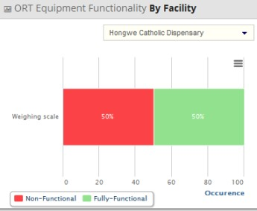

This represents the 'ORT corner equipment functionality' analysis of a specific facility in a particular district in the selected county.

In this case, Hongwe Catholic Dispensary in Lamu West District in Lamu county

### ORT Corner Equipment Location

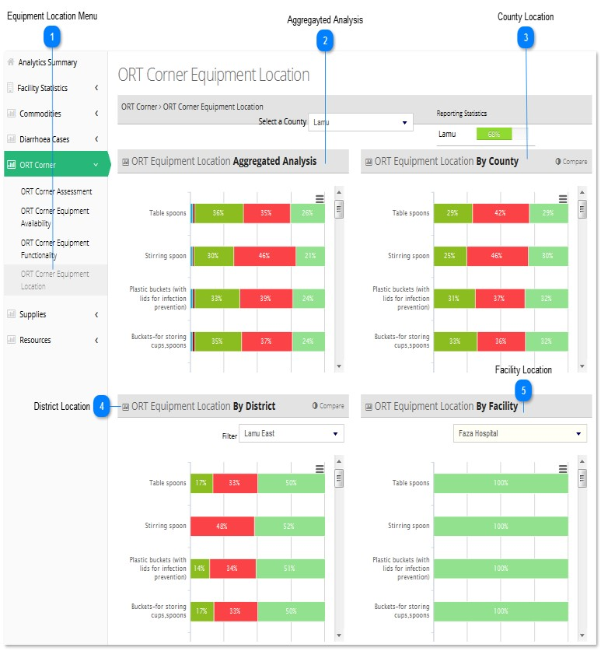

The figure above represents the 'ORT corner equipment location' analytics for Lamu County



**Equipment Location Menu**

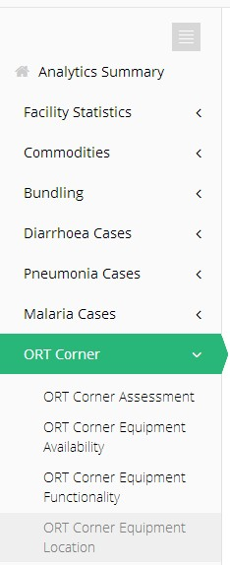

'ORT corner equipment location' is a sub-menu of the 'Facility Statistics' menu.

To access items under the 'Facility Statistics' menu, click on 'ORT corner equipment location' and the submenu shall be revealed.

In this case, 'ORT corner equipment location' of Lamu County has been selected and the various charts have been displayed.



**Aggregated Analysis**

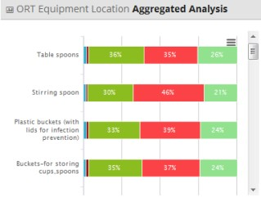

This is an aggregated analysis of the 'ORT corner equipment location' across the entire region (all counties included).



**County Location**

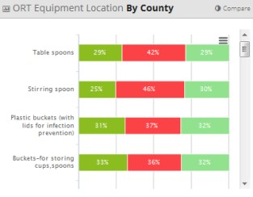

This represents the 'ORT corner equipment location' aggregated analysis of all the facilities in a specific county. In this case, all facilities located in Lamu county.



**District Location**

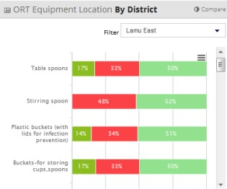

This represents the 'ORT corner equipment location' aggregated analysis of the facilities in a specific district in the selected county.

In this case, only medical facilities located in Lamu East District in Lamu county.



**Facility Location**

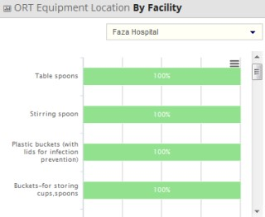

This represents the 'ORT corner equipment location' analysis of a specific facility in a particular district in the selected county.

In this case, Faza Hospital in Lamu East District in Lamu county

## SUPPLIES

This section shall focus on the 'Supplies' sub-menu of the 'Analytics' menu.

We shall review the various factors falling under 'Supplies' in detail. They are as follows:

Supplies Analytics

* Supplies Availability
* Suppliers

### Supplies Availability

### Suppliers

## RESOURCES

This section shall focus on the 'Resources' sub-menu of the 'Analytics' menu.

We shall review the various factors falling under 'Resources' in detail. They are as follows:

Resources Analytics

* Resource Availability
* Resource Location

### Resource Availability

### Resource Location